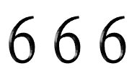
Comprehensive Biblical Decryption

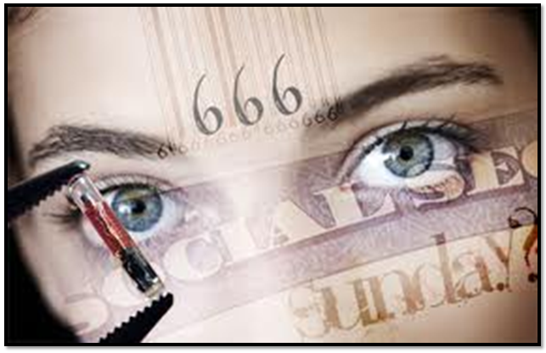

Nephilim Archenemy of Israel, an occultic king, the lord arising, the image to be worshipped by the apostate, false believers who rejected Yehushua, (covenant discipleship) will take the mark from the false prophets/ministers and be thrown in hell and tortured forever.

Nephilim Hybrid Enemy of Israel: 1 Samuel 17:4-7 “And there went out a champion out of the camp of the Philistines, named Goliath, of Gath, whose height was SIX cubits and a span. 5And he had a (1) helmet of brass upon his head, and he was armed with a (2) coat of mail; and the weight of the coat was five thousand shekels of brass. 6And he had (3) greaves of brass upon his legs, and a (4) target of brass between his shoulders. 7And the (5) staff of his spear was like a weaver's beam; and his (SIX) spear's head weighed SIX hundred shekels of iron: and one bearing a shield went before him.” ^{KJV}

Occultic King: 1 Kings 10:14 “Now the weight of gold that came to Solomon in one year was SIX HUNDRED THREESCORE (SIXTY) and SIX talents of gold” ^{KJV} {Gold – Deity, Divinity, Heavenly: Deut. 7:25, 1 Kings 6:28, Dan 3:1, Rev.2:1} {Occultic – 2Kings 23:1, 1 Kings 11}

The Arising Lord [out of the abyss]: Ezra 2:13 “The children of Adonikam, SIX HUNDRED SIXTY and SIX.” ^{KJV} {Adonkiam ‘Adoniyqam’ : ‘adown’ - The Lord, ‘quwm’ to arise = The Lord arising}

Image and Worship: Daniel 3:1, 5 “¹Nebuchadnezzar the king made an image of gold, whose height was THREESCORE (SIXTY) cubits, and the breadth thereof SIX cubits: he set it up in the plain of Dura, in the province of Babylon.” “⁵That at what time ye hear the sound of the (1) cornet, (2) flute, (3) harp, (4) sackbut, (5) psaltery, (SIX) dulcimer, and all kinds of musick, ye fall down and worship the golden image that Nebuchadnezzar the king hath set up:” ^{KJV}

Apostate False Believers Rejected Yahushua: John 6:66 “From that time many of his disciples went back, and walked no more with him.” ^{KJV}

Taking the Mark: Revelations 13:15-18 “15And he had power to give life unto the image of the beast, that the image of the beast should both speak, and cause that as many as would not worship the image of the beast should be killed. 16And he causeth all, both small and great, rich and poor, free and bond, to receive a mark in their right hand, or in their foreheads: 17And that no man might buy or sell, save he that had the mark, or the name of the beast, or the number of his name. 18Here is wisdom. Let him that hath understanding count the number of the beast: for it is the number of a man; and his number SIX HUNDRED THREESCORE (SIXTY) and SIX.” ^{KJV}

*Taking the Mark →Thrown in Hell and Tortured Forever:
Revelation 14:9-11 “⁹And the third angel followed them, saying with a loud voice, If any man worship the beast and his image, and receive his mark in his forehead, or in his hand, ¹⁰The same shall drink of the wine of the wrath of God, which is poured out without mixture into the cup of his indignation; and he shall be tormented with fire and brimstone in the presence of the holy angels, and in the presence of the Lamb: ¹¹And the smoke of their torment ascendeth up for ever and ever: and they have no rest day nor night, who worship the beast and his image, and whosoever receiveth the mark of his name.” ^{KJV}

CERN:
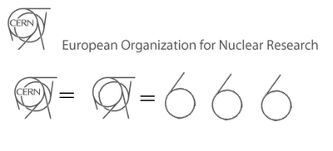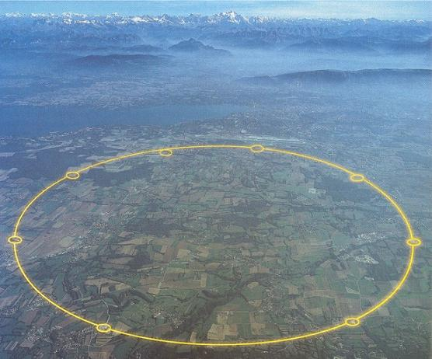
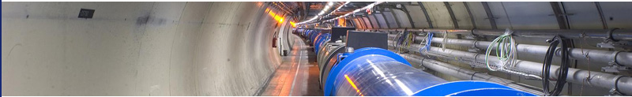

Lord Shiva: Statue at CERN Cernunnos:
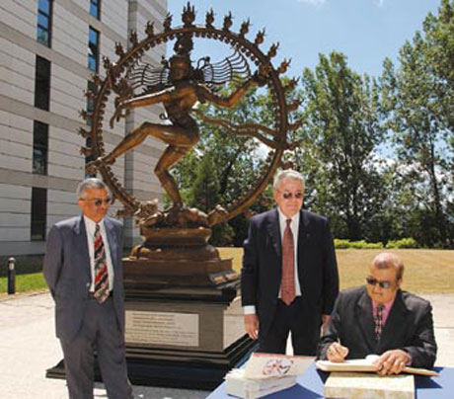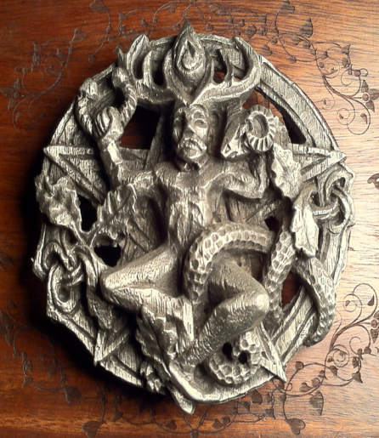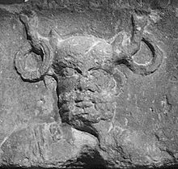

Disney:

United Nations:

666 Hand Sign: Luciferian Je-sus:
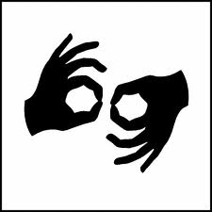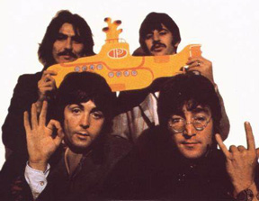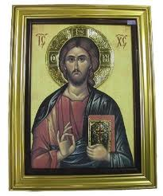

Proverbs 6:12-15 “A worthless person, a wicked man, is he who goes about with a perverse (contrary, wayward) mouth. 13 He winks with his eyes, he speaks by shuffling or tapping with his feet, he makes signs [to mislead and deceive] and teaches with his fingers. 14 Willful and contrary in his heart, he devises trouble, vexation, and evil continually; he lets loose discord and sows it. 15 Therefore upon him shall the crushing weight of calamity come suddenly; suddenly shall he be broken, and that without remedy.”^{Amplified}

