Bride of the Destroyer

Proverbs 2:17-19a
“17 of her who has forsaken the instruction of her youth, and forgotten the covenant of God. 18 For she has fixed her house near death, and guided her wheels near Hades with the giants. 19a None that go by her shall return, neither shall they take hold of right paths,” ^{Brenton Septuagint}
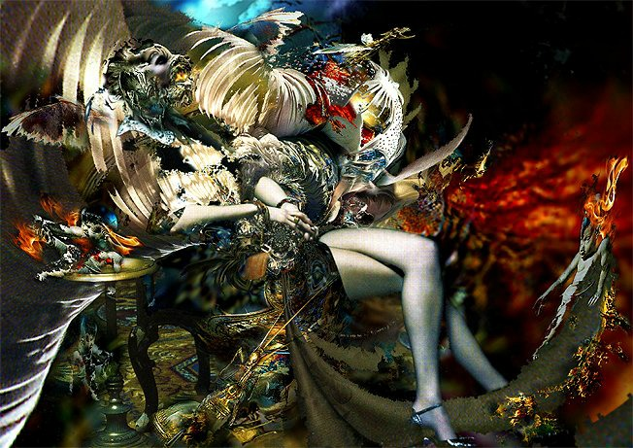

Apostasy=Adulteress Whoredom

Ezekiel 6:9 “And they that escape of you shall remember me among the nations whither they shall be carried captives, because I am broken with their whorish heart, which hath departed from me, and with their eyes, which go a whoring after their idols: and they shall lothe themselves for the evils which they have committed in all their abominations.” ^{KJV}

Jeremiah 3:3 “Therefore the showers have been withholden, and there hath been no latter rain; and thou hadst a whore's forehead, thou refusedst to be ashamed.” ^{KJV} *Deut. 32:2- Showers, rain = Rhema/doctrine of Yhvh

Corpse Bride Claiming Queen-ship

Worldly

James 4:4 “Ye adulterers and adulteresses, know ye not that the friendship of the world is enmity with God? whosoever therefore will be a friend of the world is the enemy of God.” ^{KJV}

Matthew 16:26
“For what is a man profited, if he shall gain the whole world, and lose his own soul? or what shall a man give in exchange for his soul?” ^{KJV}

Wretched, Blind and Naked

Revelation 3:17 ‘Because thou sayest, I am rich, and increased with goods, and have need of nothing; and knowest not that thou art wretched, and miserable, and poor, and blind, and naked:” ^{KJV}

Diseased

Isaiah 1:5-6 “Why should ye be stricken any more? ye will revolt more and more: the whole head is sick, and the whole heart faint. From the sole of the foot even unto the head [there is] no soundness in it; [but] wounds, and bruises, and putrifying sores: they have not been closed, neither bound up, neither mollified with ointment.” ^{KJV}

Dead

Revelation 3:1b “I know thy works, that thou hast a name that thou livest, and art dead.” ^{KJV}

James 2:26 “For as the body without the spirit is dead, so faith without works is dead also.” ^{KJV}

Liar

1 John 2:4 “He that saith, I know him, and keepeth not his commandments, is a liar, and the truth is not in him.” ^{KJV}

Odes of Solomon 38

1 I went up to the light of truth as if into a chariot: 2 And the Truth took me and led me: and carried me across pits and gulleys; and from the rocks and the waves it preserved me: 3 And it became to me a haven of Salvation: and set me on the arms of immortal life: 4 And it went with me and made me rest, and suffered me not to wander because it was the Truth; 5 And I ran no risk, because I walked with Him; 6 And I did not make an error in anything because I obeyed the Truth. 7 For Error flees away from it, and meets it not: but the Truth proceeds in the right path, and 8 Whatever I did not know, it made clear to me, all the poisons of error, and the plagues of death which they think to be sweetness: 9 And I saw the destroyer of destruction, when the bride who is corrupted is adorned: and the bridegroom who corrupts and is corrupted; 10 And I asked the Truth, 'Who are these?'; and He said to me, 'This is the deceiver and the error: 11 And they are alike in the beloved and in his bride: and they lead astray and corrupt the whole world: 12 And they invite many to the banquet, 13 And give them to drink of the wine of their intoxication, and remove their wisdom and knowledge, and so they make them without intelligence; 14 And then they leave them; and then these go about like madmen corrupting: seeing that they are without heart, nor do they seek for it.' 15 And I was made wise so as not to fall into the hands of the deceiver; and I congratulated myself because the Truth went with me, 16 And I was established and lived and was redeemed, 17 And my foundations were laid on the hand of the Lord: because He established me. 18 For He set the root and watered it and fixed it and blessed it; and its fruits are for ever. 19 It struck deep and sprung up and spread out and was full and enlarged; 20 And the Lord alone was glorified in His planting and in His husbandry: by His care and by the blessing of His lips, 21 By the beautiful planting of His right hand: and by the discovery of His planting, and by the thought of His mind. Hallelujah.

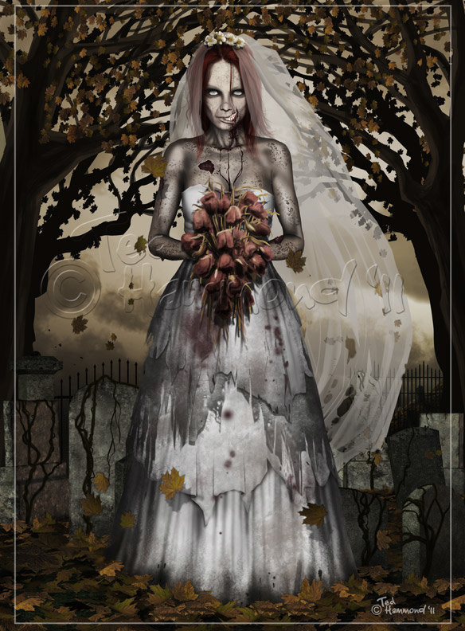

The Way
Her Way
Proverbs 7:25-27 “Let not thine heart turn aside to her ways: 26 for she has wounded and cast down many, and those whom she has slain are innumerable. 27 Her house is the way of hell, leading down to the chambers of death.” ^{Brenton Septuagint} | John 14:6 “Jesus saith unto him, I am the way, the truth, and the life: no man cometh unto the Father, but by me.” ^{KJ V}  Mat. 10:24 “The disciple is not above [his] master, nor the servant above his lord.” ^{KJV}
Psalm 119:128 “Therefore I esteem all [thy] precepts [concerning] all [things to be] right; [and] I hate every false way.” ^{KJV} | Ps. 119:1-3 “Blessed [are] the undefiled in the way, who walk in the law of the LORD. 2 Blessed [are] they that keep his testimonies, [and that] seek him with the whole heart. 3 They also do no iniquity: they walk in his ways.” ^{KJV}
Mat. 7:13 “Enter ye in at the strait gate: for wide [is] the gate, and broad [is] the way, that leadeth to destruction, and many there be which go in thereat:” ^{KJV} | Ps. 89:11 “Teach me thy way, O LORD; I will walk in thy truth: unite my heart to fear thy name.” ^{KJV}
Proverbs 18:9 “He who is slothful in his work Is a brother to him who is a great destroyer.” ^{NKJV} | Ps.119:30 “I have chosen the way of truth: thy judgments have I laid [before me].” ^{KJV}

Abiding in Nephilim Spirits

*Proverbs 9:13-18 The Foolish Woman

Pr. 9:18 “And he did not know that giants are there, and that her guests are in the depths of hell.” ^{Douay Rheims}

Pr. 9:18 “And he hath not known that Rephaim are there, In deep places of Sheol her invited ones!” ^{Young’s Literal Translation}

Pr. 2:18 “For she has fixed her house near death, and guided her wheels near Hades with the giants.” ^{Brenton Septuagint}

Pr. 2:18 “For her house hath inclined unto death, And unto Rephaim her paths.” ^{Young’s Literal Translation}

Pr. 2:18 “Surely her house leads down to death and her paths to the spirits of the dead.” ^{NIV}

Pr. 21:16 “A man that wanders out of the way of righteousness, shall rest in the congregation of giants.” ^{Brenton Septuagint}
Backslidden Divorcee

Jer. 3:8 “And I saw, when for all the causes whereby backsliding Israel committed adultery I had put her away, and given her a bill of divorce; yet her treacherous sister Judah feared not, but went and played the harlot also.” ^{KJV}
Covenant of Death in a Refuge of Lies

Isaiah 28:15 “Because ye have said, We have made a covenant with death, and with hell are we at agreement; when the overflowing scourge shall pass through, it shall not come unto us: for we have made lies our refuge, and under falsehood have we hid ourselves:” ^{KJV}

The Dead Sea Scrolls: The Seductress (4QI84)

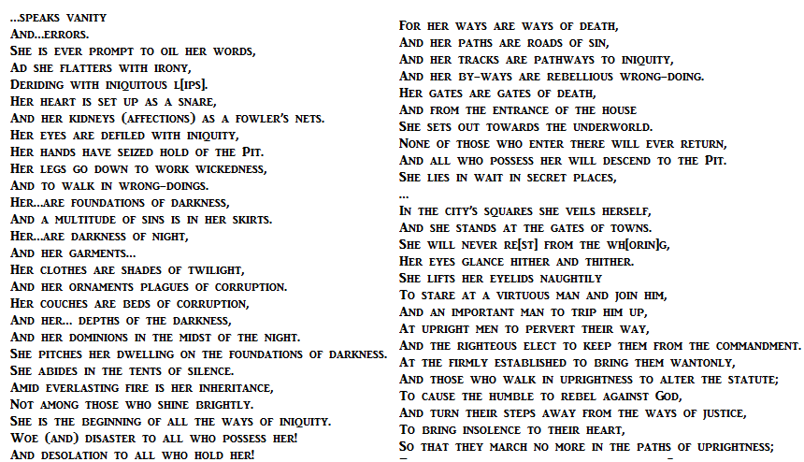

Adamant Repudiation

Proverbs 30:20 “Such [is] the way of an adulterous woman; she eateth, and wipeth her mouth, and saith, I have done no wickedness.” ^{KJV}

Revelation 18:7 “How much she hath glorified herself, and lived deliciously, so much torment and sorrow give her: for she saith in her heart, I sit a queen, and am no widow, and shall see no sorrow.” ^{KJV}

Fallen Queens of Israel

• Eve - Genesis 3:13b
• Jezebel – 2 Kings 9:22b
• Vashti – Esther 1:12
• Adulteress Woman of Proverbs - Proverbs 23:27-28
•Solomon’s Wives – 1 Kings 11

Other Scriptures of Interest
Hosea 5:4 “Their deeds will not allow them To return to their God. For a spirit of harlotry is within them, And they do not know the LORD.” ^{NASB}
Proverbs 23:27 “The whore is a deep: unsearchable/mysterious pit. The strange woman is the enemies’ well/pit.” Literal Sequential Non-Paraphrased Rendition
Proverbs 22:14 “The word/commandment of the strange woman is a mysterious pit. Those who defy/are adhored of the Lord shall be divided/fall within + rot therein.” Literal Sequential Non-Paraphrased Rendition
Leviticus 17:7, 20:6, Numbers 14:33, 15:39, Deuteronomy 31:16, Judges 2:17, 8:27, 2 Chronicles 21:11-13, Psalms 73:27, 106:39, Proverbs 23:27, Isaiah 1:21, Jeremiah 20:20, Ezekiel 16, 23, Hosea 1:2, 2:5, 4:7, 5:4, Micah 1:7, Matthew 12:39, Revelation 2:20

