Holy Armour
Psalms 110:1-3 “The word of God to my Lord:
"Sit alongside me here on my throne until I make your enemies a
stool for your feet." You were forged a strong scepter by God of Zion;
now rule, though surrounded by enemies! Your people will freely
join you, resplendent in holy armor on the great day of your
conquest, Join you at the fresh break of day, join you with
all the vigor of youth.” ^{Message Bible}

Yahweh
Psalm 93:1 “The LORD reigneth, he is clothed with majesty; the LORD is clothed with strength, [[wherewith]] he hath girded himself: the world also is stablished, that it cannot be moved.” ^{KJV}

Psalm 65:6 “Who established the mountains by His strength, [[Being]] clothed with power;” ^{NKJV}

Job 40:10 “Deck thyself now with glory and excellency, and clothe thyself with majesty and splendour.” ^{Darby}

Yahushua
Isaiah 59:17-18 “For he put on righteousness as a breastplate, and an helmet of salvation upon his head; and he put on the garments of vengeance [[for]] clothing, and was clad with zeal as a cloke. 18 According to [[their]] deeds, accordingl he will repay, fury to his adversaries, recompence to his enemies; to the islands he will repay recompence.” ^{KJV}

Isaiah 11:5 “Righteousness shall be the belt of His loins, And faithfulness the belt of His waist.” ^{NKJV}

Isaiah 11:1-2 “And there shall come forth a rod out of the stem of Jesse, and a Branch shall grow out of his roots: 2 And the spirit of the LORD shall rest upon him (as clothing), the spirit of wisdom and understanding, the spirit of counsel and might, the spirit of knowledge and of the fear of the LORD;” ^{KJV} | Matthew 14:35-36 “And when the men of that place had knowledge of him, they sent out into all that country round about, and brought unto him all that were diseased; 36 And besought him that they might only touch the hem of his garment: and as many as touched were made perfectly whole.” ^{KJV}
⤷John 14:30 “Hereafter I will not talk much with you: for the prince of this world cometh, and hath nothing in me.” ^{KJV}

Isaiah 63:1 “Who [is] this that cometh from Edom, with dyed garments from Bozrah? this [that is]] glorious in his apparel, travelling in the greatness of his strength? I that speak in righteousness, mighty to save.” ^{KJV}

Matthew 17:2 ”And was transfigured before them: and his face did shine as the sun, and his raiment was white as the light.” ^{KJV}
Prototypes

ELIJAH/ELISHA
1 Kings 19:19 “So he departed thence, and found Elisha the son of Shaphat, who [was] plowing [with] twelve yoke [of oxen] before him, and he with the twelfth: and Elijah passed by him, and cast his mantle upon him.” ^{KJV}

2 Kings 2:8 “And Elijah took his mantle, and wrapped[[it] together, and smote the waters, and they were divided hither and thither, so that they two went over on dry ground.” ^{KJV}

2 Kings 2:13-14 “He took up also the mantle of Elijah that fell from him, and went back, and stood by the bank of Jordan; 14 And he took the mantle of Elijah that fell from him, and smote the waters, and said, Where [is] the LORD God of Elijah? and when he also had smitten the waters, they parted hither and thither: and Elisha went over.” ^{KJV}

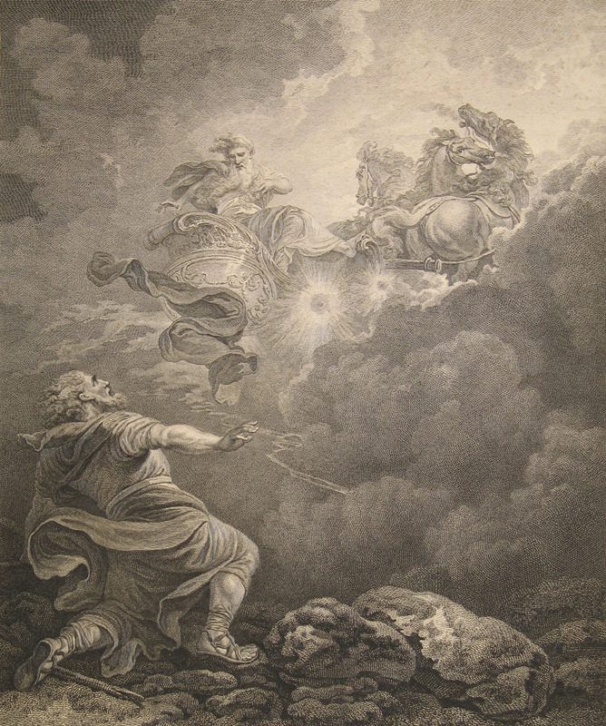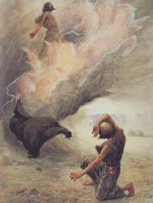

ADAM/EVE
Forgotten Books of Eden 11:8a “O Eve! Remember the glory that rested on us in the garden”

Forgotten Books if Eden 22:4a “Then God said to Adam, “So long as thou wast keeping My commandment, My light and My grace rested on thee.

Genesis 3;7 “And the eyes of them both were opened, and they knew that they [were] naked; and they sewed fig leaves together, and made themselves aprons.” ^{KJV}

JOB
Job 29:12-17 “Because I delivered the poor that cried, and the fatherless, and [him that had] none to help him. 13 The blessing of him that was ready to perish came upon me: and I caused the widow's heart to sing for joy. 14 I put on righteousness, and it clothed me: my judgment [was] as a robe and a diadem. 15 I was eyes to the blind, and feet [was] I to the lame. 16 I [was] a father to the poor: and the cause [which] I knew not I searched out. 17 And I brake the jaws of the wicked, and plucked the spoil out of his teeth.” ^{KJV}

JOSEPH
Genesis 37:3 “Now Israel loved Joseph more than all his children, because he [was] the son of his old age: and he made him a coat of [many] colours.” ^{KJV}

PREISTS
2 Chronicles 6:41 “Now therefore arise, O LORD God, into thy resting place, thou, and the ark of thy strength: let thy priests, O LORD God, be clothed with salvation, and let thy saints rejoice in goodness.” ^{KJV}

Psalm 132:9, 16 “Let thy priests be clothed with righteousness; and let thy saints shout for joy 16 I will also clothe her priests with salvation: and her saints shall shout aloud for joy.” ^{KJV}

ZION
Isaiah 52:1 “Awake, awake; clothe/array/arm (“labash”) thyself with strength, O Zion; array thyself beautiful/glory/splendorous garments, O Jerusalem, the holy city: for henceforth there shall no more come into thee the uncircumcised and the unclean.” Literal Sequential Non-Paraphrased Rendition

GARMENT OF OBEDIENCE: ISRAEL
Numbers 15:38 “Speak unto the children of Israel, and bid them that they make them fringes in the borders of their garments throughout their generations, and that they put upon the fringe of the borders a rib and of blue:” ^{KJV}
OVERCOMERS
1 Enoch 62:16 “And they shall have been clothed with garments of glory, And they shall be the garments of life from the Lord of Spirits: And your garments shall not grow old , Nor your glory pass away before the Lord of Spirits.” ^{R.H. Charles}

ZECHARIAH
2 Chronicles 24:20 “And the Spirit of God clothed/arrayed/armed (“labash”) Zechariah the son of Jehoiada the priest, which stood above the people, and said unto them, Thus saith God, Why transgress ye the commandments of the LORD, that ye cannot prosper? because ye have forsaken the LORD, he hath also forsaken you.” Literal Sequential Non-Paraphrased Rendition

GIDEON
Judges 6:34 “But the Spirit of the LORD clothed/arrayed/armed (“labash”) Gideon, and he blew a trumpet; and Abiezer was gathered after him.” Literal Sequential Non-Paraphrased Rendition

Cladded Shrouding/Garments of Darkness/Corruption

Shame/Dishonour
Psalm 35:26 “Let them be ashamed and brought to confusion together that rejoice at mine hurt: let them be clothed with shame and dishonour that magnify [themselves] against me.” ^{KJV}

Drowsiness
Proverbs 23:21 “For the drunkard and the glutton shall come to poverty: and drowsiness shall clothe [a man] with rags.” ^{KJV}

Pride/Violence
Psalm 73:6 “Therefore pride compasseth them about as a chain; violence covereth them [as] a garment.” ^{KJV}
See also Malachi 2:16

Defilement
Jude 1:23 “but others save with fear, pulling [them] out of the fire, hating even the garment defiled by the flesh.” ^{NKJV}

Rebellion-False Covering
Isaiah 30:1 “Woe to the rebellious children, saith the LORD, that take counsel, but not of me; and that cover with a covering, but not of my spirit, that they may add sin to sin:” ^{KJV}

Cursed Vesture
Psalm 109:18 “As he clothed himself with cursing like as with his garment, so let it come into his bowels like water, and like oil into his bones.” ^{KJV}

Mantle of Confusion
Psalm 109:29 “Let mine adversaries be clothed with shame, and let them cover themselves with their own confusion, as with a mantle.” ^{KJV}

Guises/Façades
Matthew 7:15 “Beware of false prophets, which come to you in sheeps clothing, but inwardly they are ravening wolves.” ^{KJV}
Externalism/Playacting
Matthew 23:27 “Woe to you, scribes and Pharisees, hypocrites! For you are like whitewashed tombs which indeed appear beautiful outwardly, but inside are full of dead [men’s]]bones and all uncleanness.” ^{NKJV}

Zechariah 3:1-8 “And he shewed me Joshua the high priest standing before the angel of the LORD, and Satan standing at his right hand to resist him. 2 And the LORD said unto Satan, The LORD rebuke thee, O Satan; even the LORD that hath chosen Jerusalem rebuke thee: [is] not this a brand plucked out of the fire? 3 Now Joshua was clothed with filthy garments, and stood before the angel. 4 And he answered and spake unto those that stood before him, saying, Take away the filthy garments from him. And unto him he said, Behold, I have caused thine iniquity to pass from thee, and I will clothe thee with change of raiment. 5 And I said, Let them set a fair mitre upon his head. So they set a fair mitre upon his head, and clothed him with garments. And the angel of the LORD stood by. 6 And the angel of the LORD protested unto Joshua, saying, 7 Thus saith the LORD of hosts; If thou wilt walk in my ways, and if thou wilt keep my charge, then thou shalt also judge my house, and shalt also keep my courts, and I will give thee places to walk among these that stand by. 8 Hear now, O Joshua the high priest, thou, and thy fellows that sit before thee: for they [are] men wondered at: for, behold, I will bring forth my servant the BRANCH.” ^{KJV}

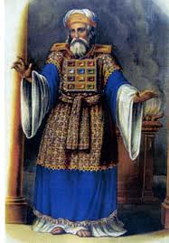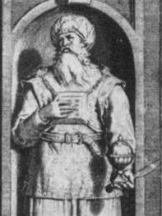

Filthy Rags Contextualized
Isaiah 64:5-7 “Thou meetest him that rejoiceth and worketh righteousness, [those that] remember thee in thy ways: behold, thou art wroth; for we have sinned: in those is continuance, and we shall be saved. 6 But we are all as an unclean [thing], and all our righteousnesses [are] as filthy rags; and we all do fade as a leaf; and our iniquities, like the wind, have taken us away. 7 And [there is] none that calleth upon thy name, that stirreth up himself to take hold of thee: for thou hast hid thy face from us, and hast consumed us, because of our iniquities.” ^{KJV}
Job 30:18 “A vast array of reptiles “koach” garment me, searching out/disguising/changing/distorting, encompassing me, opening my inner garment.” Literal Sequential Non Paraphrased Rendition

Job 30:18 “By great force my garment is disfigured; It binds me about as the collar of my coat.” ^{NKJV}

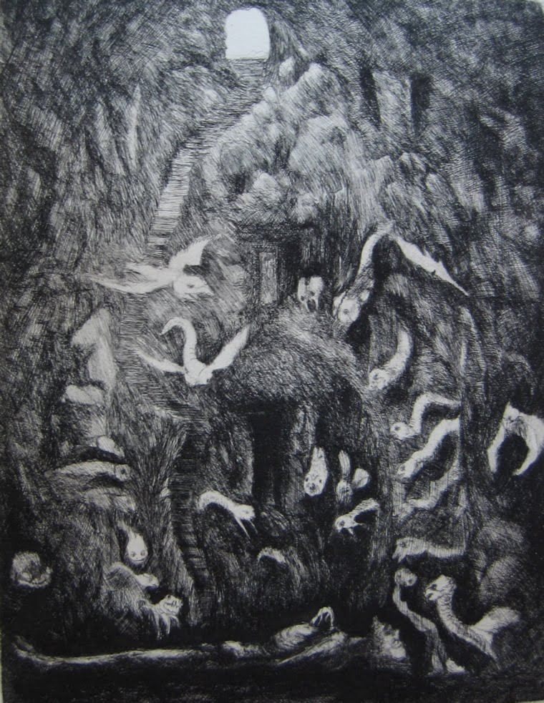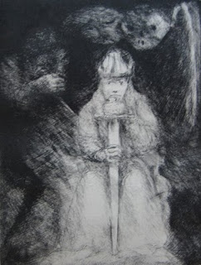

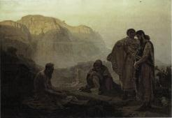

Job 30:29 “I am a brother to dragons, and a companion to owls.” ^{KJV}

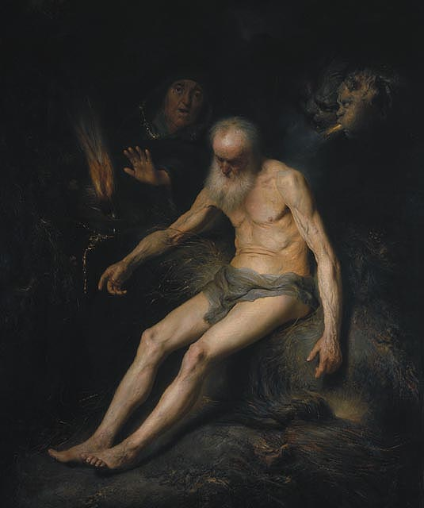
Nakedness

Isaiah 59:6 “Their webs shall not become garments, neither shall they cover themselves with their works: their works [are] works of iniquity, and the act of violence [is] in their hands.” ^{KJV}

Revelation 3:15-18 “I know thy works, that thou art neither cold nor hot: I would thou wert cold or hot. 16 So then because thou art lukewarm, and neither cold nor hot, I will spue thee out of my mouth. 17 Because thou sayest, I am rich, and increased with goods, and have need of nothing; and knowest not that thou art wretched, and miserable, and poor, and blind, and naked: 18 I counsel thee to buy of me gold tried in the fire, that thou mayest be rich; and white raiment, that thou mayest be clothed, and [that] the shame of thy nakedness do not appear; and anoint thine eyes with eyesalve, that thou mayest see.” ^{KJV}

Exodus 32:25 “And when Moses saw that the people [were] naked; (for Aaron had made them naked unto [their]] shame among their enemies:)” ^{KJV}

Hosea 2:2-3 “Plead with your mother, plead: for she [is] not my wife, neither [am] I her husband: let her therefore put away her whoredoms out of her sight, and her adulteries from between her breasts; 3 Lest I strip her naked, and set her as in the day that she was born, and make her as a wilderness, and set her like a dry land, and slay her with thirst.” ^{KJV}
SHAME ⟼ Isaiah 20:4, 47:3

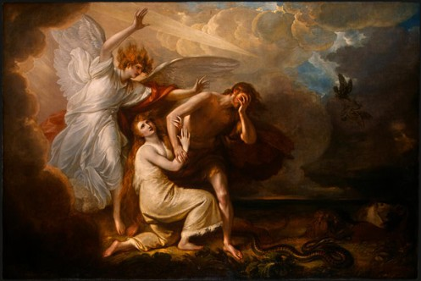
Arrayal of the Victorious Elect

Revelation 3:5 “'He who overcomes will thus be clothed in white garments; and I will not erase his name from the book of life, and I will confess his name before My Father and before His angels.” ^{N.A.S.B.}

OVERCOMER’S VESTURE

⇒Ecclesiastes 9:8 “Let thy garments be always white; and let thy head lack no ointment.” ^{KJV}

Offered by Grace
James 1:17 “Every good gift and every perfect gift is from above, and cometh down from the Father of lights, with whom is no variableness, neither shadow of turning.” ^{KJV}

Given/Received of Few
Revelation 3:4 “Thou hast a few names even in Sardis which have not defiled their garments; and they shall walk with me in white: for they are worthy” ^{KJV}

Bought From Christ
Revelation 3:18 “I counsel thee to buy of me gold tried in the fire, that thou mayest be rich; and white raiment, that thou mayest be clothed, and [that] the shame of thy nakedness do not appear; and anoint thine eyes with eyesalve, that thou mayest see.” ^{KJV}

Matthew 19:21 “Jesus said unto him, If thou wilt be perfect, go [and] sell that thou hast, and give to the poor, and thou shalt have treasure in heaven: and come [and] follow me.” ^{KJV}

Granted Unto Martyrs
Revelation 6:9-11 “And when he had opened the fifth seal, I saw under the altar the souls of them that were slain for the word of God, and for the testimony which they held: 10 And they cried with a loud voice, saying, How long, O Lord, holy and true, dost thou not judge and avenge our blood on them that dwell on the earth? 11 And white robes were given unto every one of them; and it was said unto them, that they should rest yet for a little season, until their fellowservants also and their brethren, that should be killed as they [were], should be fulfilled.” ^{KJV}

Washed in Repentance- Great Tribulation
Revelation 7:13 -14 “And one of the elders answered, saying unto me, What are these which are arrayed in white robes? and whence came they? 14 And I said unto him, Sir, thou knowest. And he said to me, These are they which came out of great tribulation, and have washed their robes, and made them white in the blood of the Lamb.” ^{KJV}

Kept/Lost
Revelation 16:15 “Behold, I come as a thief. Blessed [is] he that watcheth, and keepeth his garments, lest he walk naked, and they see his shame.” ^{KJV}

Righteousness/Righteous Acts
Revelation 19:8 “It was given to her to clothe herself in fine linen, bright and clean; for the fine linen is the righteous acts of the saints.” ^{N.A.S.B.}

Obedience to Yahweh’s Law
2 Esdras 2:39-47 “Which are departed from the shadow of the world, and have received glorious garments of the Lord. 40 Take thy number, O Sion, and shut up those of thine that are clothed in white, which have fulfilled the law of the Lord. 41 The number of thy children, whom thou longedst for, is fulfilled: beseech the power of the Lord, that thy people, which have been called from the beginning, may be hallowed. 42 I Esdras saw upon the mount Sion a great people, whom I could not number, and they all praised the Lord with songs. 43 And in the midst of them there was a young man of a high stature, taller than all the rest, and upon every one of their heads he set crowns, and was more exalted; which I marvelled at greatly. 44 So I asked the angel, and said, Sir, what are these? 45 He answered and said unto me, These be they that have put off the mortal clothing, and put on the immortal, and have confessed the name of God: now are they crowned, and receive palms. 46 Then said I unto the angel, What young person is it that crowneth them, and giveth them palms in their hands? 47 So he answered and said unto me, It is the Son of God, whom they have confessed in the world. Then began I greatly to commend them that stood so stiffly for the name of the Lord.” ^{Apocrypha}

Condemnation to Those Devoid of Yet Accepting Invitation of Salvation
Matthew 22:11-14 “And when the king came in to see the guests, he saw there a man which had not on a wedding garment: 12 And he saith unto him, Friend, how camest thou in hither not having a wedding garment? And he was speechless. 13 Then said the king to the servants, Bind him hand and foot, and take him away, and cast [him] into outer darkness; there shall be weeping and gnashing of teeth. 14 For many are called, but few [are] chosen.” ^{KJV}

*Strongs 3847 “labash” לָבַשׁ –clothe, put on, array, wear, armed, apparel, clothed them*

Revelation 12:1-2 “And there appeared a great wonder in heaven; a woman clothed with the sun, and the moon under her feet, and upon her head a crown of twelve stars:” ^{KJV}

Malachi 4:2 “But unto you that fear my name shall the Sun of righteousness arise with healing in his wings; and ye shall go forth, and grow up as calves of the stall.” ^{KJV}

Psalm 84:11 “For the LORD God [is] a sun and shield: the LORD will give grace and glory: no good [thing] will he withhold from them that walk uprightly.” ^{KJV}

Baruch 4:1-3 “Put off, O Jerusalem, the garment of thy mourning and affliction, and put on the comeliness of the glory that cometh from God forever. 2 Cast about thee a double garment of the righteousness which cometh from God; and set a diadem on thine head of the glory of the Everlasting. 3 For God will shew thy brightness unto every country under heaven.” ^{Brenton Septuagint}

Matthew 17:1-4 “And after six days Jesus takes with himself Peter and James and John his brother, and He brings them up into a mountain, a lofty one, in private. And the manner of His outward expression was changed before them, that expression coming from and being representative of His inner being, And His face took on a different appearance so that it shone like the sun, and His outer garments became white like its light. And behold, there appeared to them Moses and Elijah talking with Him.” ^{Kenneth S. Wuest}

