Inner Earth
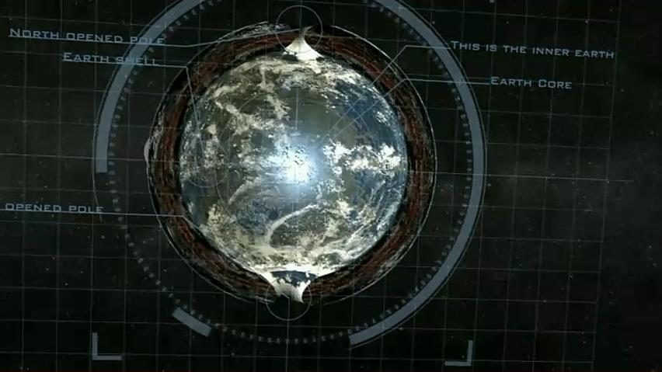Revelation 5:3 “And no man in heaven, nor in earth, neither under the earth, was able to open the book, neither to look thereon.” ^{KJV}
Revelation 5:13 “And every creature which is in heaven, and on the earth, and under the earth, and such as are in the sea, and all that are in them, heard I saying, Blessing, and honour, and glory, and power, [be] unto him that sitteth upon the throne, and unto the Lamb for ever and ever.” ^{KJV}
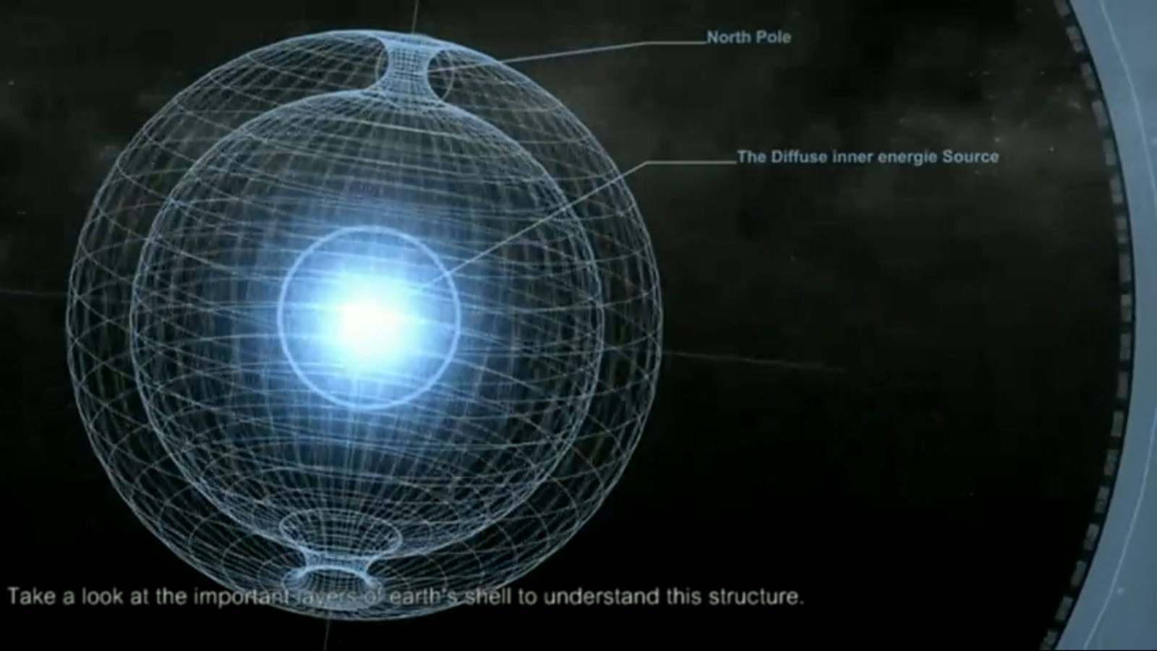
Exodus 20:4 “Thou shalt not make unto thee any graven image, or any likeness [of any thing] that [is] in heaven above, or that [is] in the earth beneath, or that [is] in the water under the earth:” ^{KJV}
Psalm 139:15 “My substance was not hid from thee, when I was made in secret, [and] curiously wrought in the lowest parts of the earth.” ^{KJV}

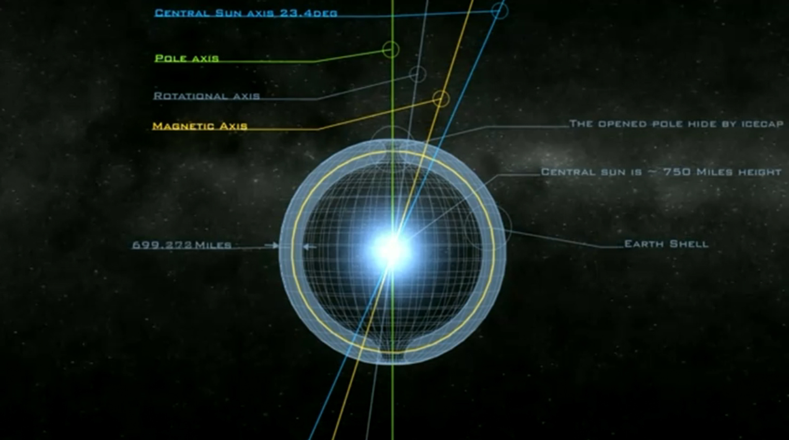

Sheol

Proverbs 15:24 “The path of life leads upward for the wise That he may keep away from Sheol below.” ^{NASB}

- subterranean place of think darkness
- a hollow subterranean place
- the underworld
- netherworld
- abode of the dead
- KJV rendered: grave, hell, pit

>Genesis 42:38, Numbers 16:30, 33, 1 Samuel 2:6, Psa;lm 16:10, Isaiah 14:9, 11, 15, Amos 9:2

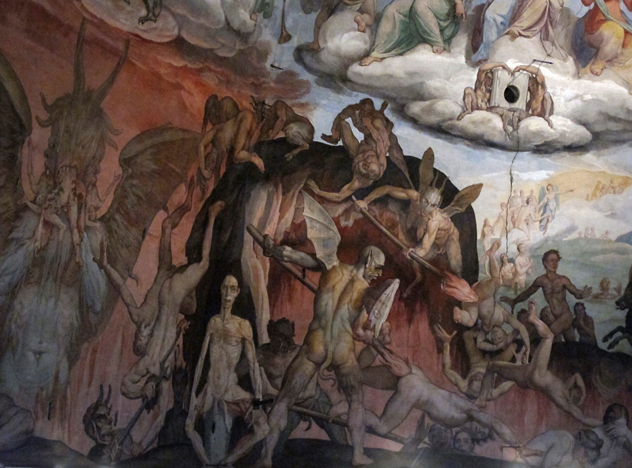
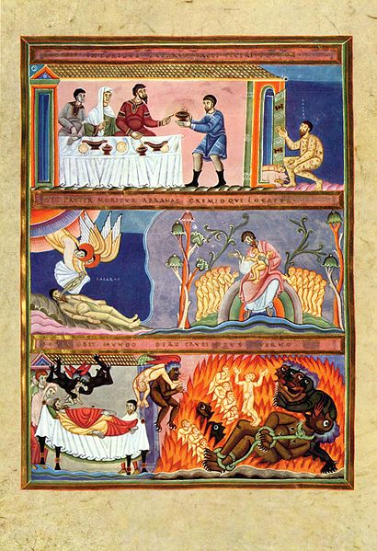
1 Enoch 22 “and there was in it four hollow places, deep and wide and very smooth. How smooth are the hollow places and deep and dark to look at. 3 Then Raphael answered, one of the holy angels who was with me, and said unto me : ‘These hollow places have been created for this very purpose, that the spirits of the souls of the dead should assemble tehrein, yea that all the souls of the children of men should assemble here. 4 And these places have been made to receive them till the day of their judgement and till their appointed period [till the period appointed], till the great judgement (comes) upon them.’ 5 I saw the spirits of the children of men who were dead, and their voice went forth to heaven and made suit. 6 Then I asked Raphael the angel who was with me, and I said unto him: This spirit- whose is it whose voice goeth forth and maketh suit?’ 7 And he answered me saying: ‘This is the spirit which went forth from Abel whom his brother Cain slew, and he makes his suit against him till his seed is destroyed from the face fo the earth, and his seed is annihilated from amongst the seed of men.’ 8 Then I asked regarding it, and regarding all the hollow places: ‘Why is one separated from the other?’ 9 And he answered me and said unto me: ‘These three have been made that the spirits of the dead might be separated. And such a division has been made <for> the spirits of the righteous in which there is the bright spring of water. 10 And such has been made for sinners when they die and are buried in the earth and judgement has not been executed on them in their lifetime. 11 Here their spirits shall be set apart in this great pain till the great day of judgement and punishment and torment of those who curse for ever, and retribution for their spirits. There He shall bind them for ever. 12 And such a divisionhas been made for the spirits of those who make their suit, who make disclosures concerning their destruction, when they were slain in the days of the sinners. 13 Such has been made for the spirits of men who were not righteous but sinners, who were complete in trasgression, and of the transgressors they shall be companions: but their spirits shall not be slain in the day of judgement nor shall they be raised from thence. 14 Then I blessed the Lord of glory and said: ‘Blessed be my Lord, the Lord of righteousness, who ruleth for ever.’” ^{R.H. Charles}

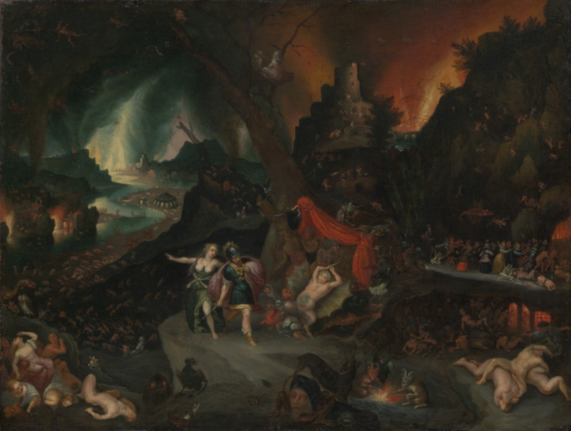

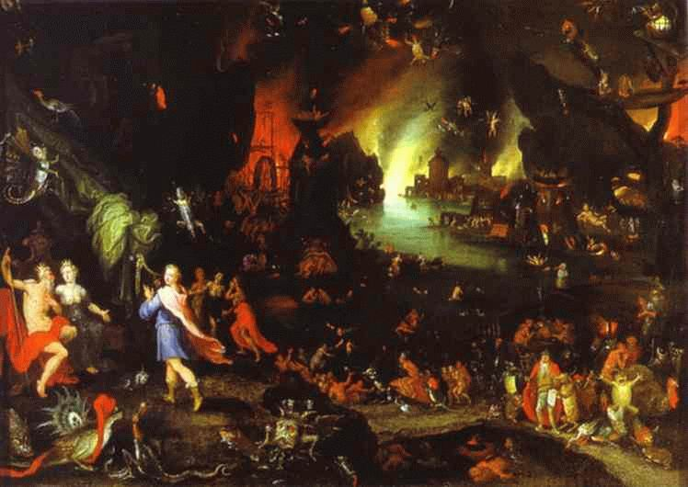
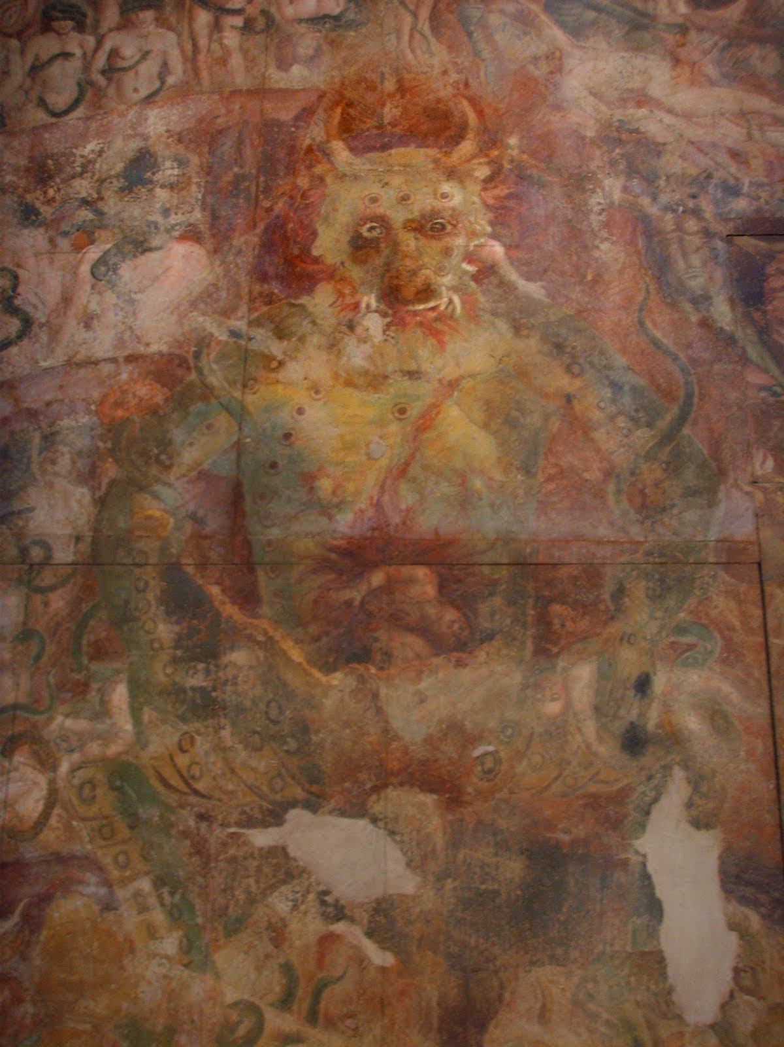
pit

Job 33:28:30 “He will deliver his soul from going into the pit, and his life shall see the light. 29 Lo, all these [things] worketh God oftentimes with man, 30 To bring back his soul from the pit, to be enlightened with the light of the living.” ^{NASB}

-“shachath”: pit, sepulchre (Isaiah 38:17)
- “bowr” : pit, sepulchre, cistern, prison (Proverbs 1:12)
-“pachath” : a pit (2 Samuel 18:17)

>Job 17:16, Psalm 140:10. 88:6, Isaiah 14:15, Ezekiel 28:8, 32:24, Zechariah 9:11, Revelation 9:2

Ezekiel 26:20 “When I shall bring thee down with them that descend into the pit, with the people of old time, and shall set thee in the low parts of the earth, in places desolate of old, with them that go down to the pit, that thou be not inhabited; and I shall set glory in the land of the living;” ^{KJV}

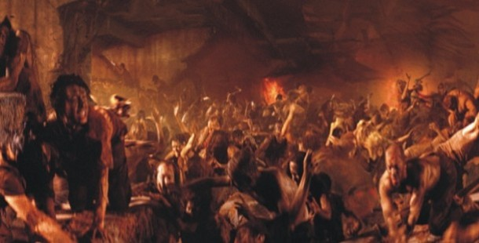
Hades

Revelation 20:13:14 “And the sea gave up the dead which were in it, and death and Hades gave up the dead which were in them; and they were judged, every one of them according to their deeds. 14 Then death and Hades were thrown into the lake of fire. This is the second death, the lake of fire.” ^{NASB}

- hades/pluto
- the god of lower region
- netherworld
- infernal regions
- receptacle of disembodied spirits (Matthew 11:23)

>Matthew 16:18, Revelation 1:8, 6:8, 20:13-14
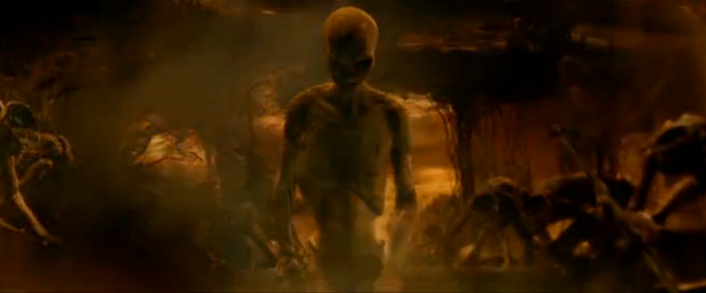
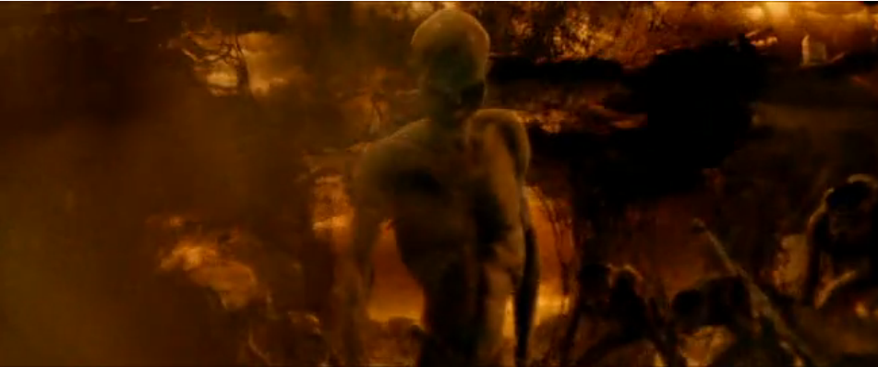
Abyss

Revelation 9:1 “And the fifth messenger did sound, and I saw a star out of the heaven having fallen to the earth, and there was given to it the key of the pit of the abyss” ^{Young’s Literal Translation}

- unbounded
- bottomless
- immeasurable death
- a pit
- very deep gulf
- chasm lowest part of the earth
-abode of the demons
>Revelation 9:11, 11:7, 17:8, 20:1, 3

Psalm 104:6 “The abyss! as with clothing Thou hast covered it, Above hills do waters stand.” ^{Young’s Literal Translation}

The Book of Jubilees 6:27a “The abysses of the earth wer eopened. And the waters began to descend into them.” ^{R.H. Charles}

Sonar Imaging Eyjafjallajökull Volcano 15-3-2010
The Deep

Psalm 71:20 “[Thou], which hast shewed me great and sore troubles, shalt quicken me again, and shalt bring me up again from the depths of the earth.” ^{KJV}

Desolation, Emptiness, Confusion, Darkness  Genesis 1:2 | Judgement  Genesis 7:11 | Hidden/Concealed  Job 38:30
Leviathon  Job 41:31-32 | Judgements  Psalm 36:6 | Peril/Pit  Psalm 69:2, 14-15
Young’s Literal Translation: Abyss  Psalm 104:6 | Yhwh’s Omnipotence  Psalm 135:6 | Burning/Fallen  Psalm 140:10
Harlot  Proverbs 22:14, 23:27 | Tophet  Isaiah 30:33 | Dragons  Psalm 148:7
Yah’s Power overDeliverance  Isaiah 51:9-11, 63:13 | CoveringDesolation  Ezekiel 26:19 | Fire  Amos 7:4
Pit/Darkness  Psalm 88:6 | Place of Foreign Army Abiding in Death  Nehemiah 9:11, Exodus 15:5,8 | Eternal Resting Place of Sin  Micah 7:19

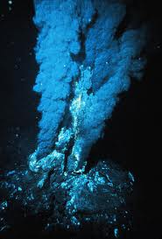
Geographic/prophetic Underworld

Hinnom Valley

Jeremiah 7:31-32 “And they have built the high places of Tophet, which [is] in the valley of the son of Hinnom, to burn their sons and their daughters in the fire; which I commanded [them] not, neither came it into my heart. 32 Therefore, behold, the days come, saith the LORD, that it shall no more be called Tophet, nor the valley of the son of Hinnom, but the valley of slaughter: for they shall bury in Tophet, till there be no place.” ^{KJV}

-deep ravine directly south of Jerusalem (Joshua 15:8)
-place of worship of foreign gods “Molech” (2 Kings 23:10)
- place of worship Baal (Jeremiah 32:35)
-place of those partaking in the torture and murder of children (2 Kings 23:10,
2 Chronicles 28:3, Jeremiah 7:31)
-associated with worshipping fallen entities and occultism (2 Chornicles 33:3-6)
-prophetically proclaimed as a place of mass burial (Jeremiah 7:32)
-denoted as a place of catastrophic punishment, burial, feasting upon corpses, burning, doom, submission to to other gods, forced consuption of human flesh, irreparableness (Jeremiah 19:12)
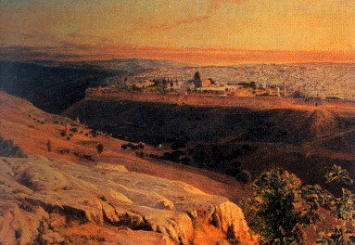
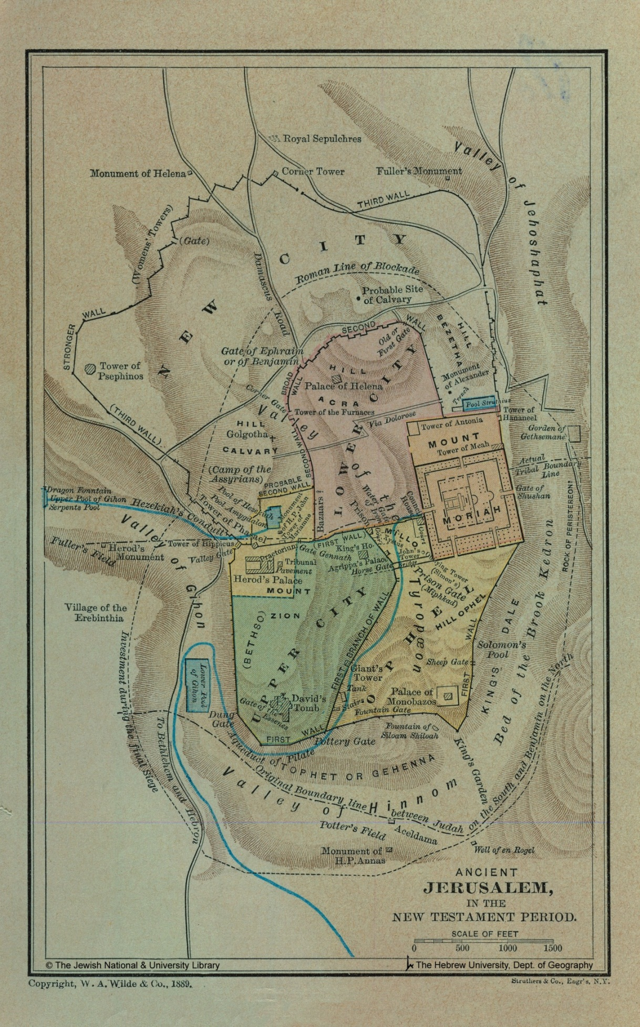Tophet

Isaiah 30:33 “For Tophet [is] ordained of old; yea, for the king it is prepared; he hath made [it] deep [and] large: the pile thereof [is] fire and much wood; the breath of the LORD, like a stream of brimstone, doth kindle it.” ^{KJV}

-geographic location within the valley of Hinnom (Jeremiah 7:31)
- that which is spit upon
-that which is upon
-spittle
-place of burning
-fire stove
-place of graves
-place of torture and murder of children (Jeremiah 7:31)
-regularly mentioned/coupled within valley of Hinnom (Jeremiah 19)
-Hell? (Isaiah 30:33)

>Jeremiah 5:14, Isaiah 30:33=Revelation13, Isiaiah 10:12-14, Isaiah 3:24-27

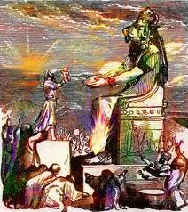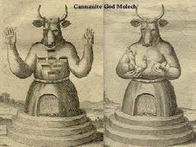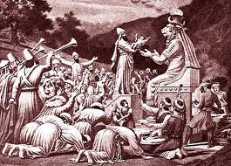

Ghenna

Matthew 5:29 “And if thy right eye offend thee, pluck it out, and cast [it] from thee: for it is profitable for thee that one of thy members should perish, and not [that] thy whole body should be cast into hell [Gehenna].” ^{KJV}

-burning garbage dump; perpetually aflame
-place of refuse; adjacent to dung/refuse gate on Jerusalem’s south wall
-place in which dead animals/cadavers of criminals were discarded/burned
-place of eternal fire + judgement
-place of damnation in which the condemned were cast into
-used as “hell” 9 times in the KJV

>Matthew 9:43-47, 23:33

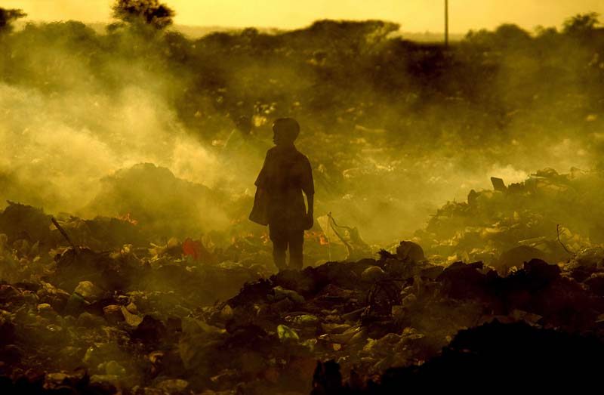
Valley of Giants (Rephaim)

*Geographic location of Valley of Hinnom, Tophet, Ghenna
Joshua 15:8 “And the border went up by the valley of the son of Hinnom unto the south side of the Jebusite; the same [is] Jerusalem: and the border went up to the top of the mountain that [lieth] before the valley of Hinnom westward, which [is] at the end of the valley of the giants northward:” ^{KJV}

Joshua 18:16 “And the border came down to the end of the mountain that [lieth] before the valley of the son of Hinnom, [and] which [is] in the valley of the giants on the north, and descended to the valley of Hinnom, to the side of Jebusi on the south, and descended to Enrogel” ^{KJV}

*Location of preparatory Military abode of Philistine giants/hybrids
2 Samuel 5:17:18 “But when the Philistines heard that they had anointed David king over Israel, all the Philistines came up to seek David; and David heard [of it], and went down to the hold. 18 The Philistines also came and spread themselves in the valley of Rephaim.” ^{KJV}

2 Samuel 23:13 “And three of the thirty chief went down, and came to David in the harvest time unto the cave of Adullam: and the troop of the Philistines pitched in the valley of Rephaim.” ^{KJV} (1 Chronicles 11:15)

1 Chronicles 14:9 “And the Philistines came and spread themselves in the valley of Rephaim.” ^{KJV}

*Place in which grapes are collected and escape from and which chaff descend into
Isaiah 17:5:6 “It shall be as when the harvester gathers the grain, And reaps the heads with his arm; It shall be as he who gathers heads of grain In the Valley of Rephaim. 6 Yet gleaning grapes will be left in it, Like the shaking of an olive tree, Two [or] three olives at the top of the uppermost bough, Four [or] five in its most fruitful branches," Says the LORD God of Israel.” ^{NKJV}

*Speaking of God’s people
>Hosea 9:10, Matthew 13:30, John 15:1-8
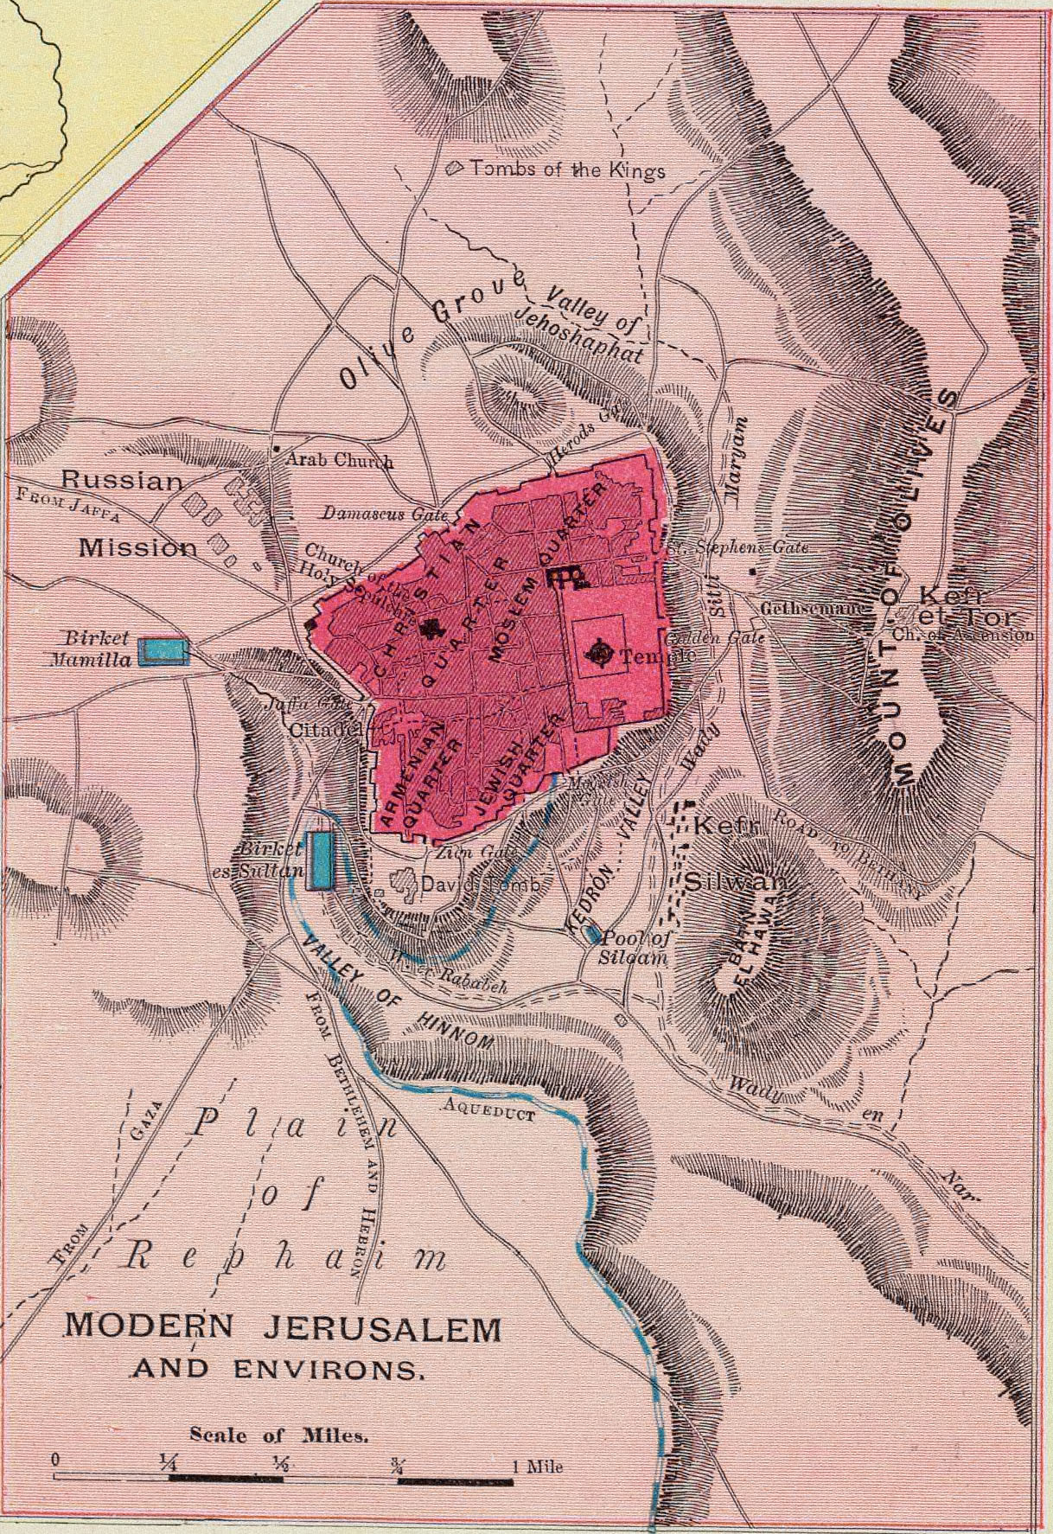
Dead Sea/Sodom & Gomorrah

-the dead sea is the lowest place on the planet, desolate of life
-has no outlets
-many vents/hot springs with sulfurous odours
-water if drank can have mortal effects
-multiple finds of sulfur/brimstone have been found on its shores
-salt causes human bouyancy

Genesis 19:28 “Then he looked toward Sodom and Gomorrah, and toward all the land of the plain; and he saw, and behold, the smoke of the land which went up like the smoke of a furnace.” ^{NKJV}

Matthew 13:42 “And shall cast them into a furnace of fire: there shall be wailing and gnashing of teeth.” ^{KJV} (See also Revelation 9:2)

Jude 1:7 “Even as Sodom and Gomorrha, and the cities about them in like manner, giving themselves over to fornication, and going after strange flesh, are set forth for an example, suffering the vengeance of eternal fire.” ^{KJV}

2 Esdras 5:4-9 “But if the most High grant thee to live, thou shalt see after the third trumpet that the sun shall suddenly shine again in the night, and the moon thrice in the day: 5 And blood shall drop out of wood, and the stone shall give his voice, and the people shall be troubled: 6 And even he shall rule, whom they look not for that dwell upon the earth, and the fowls shall take their flight away together: 7 And the Sodomitish sea shall cast out fish, and make a noise in the night, which many have not known: but they shall all hear the voice thereof. 8 There shall be a confusion also in many places, and the fire shall be oft sent out again, and the wild beasts shall change their places, and menstruous women shall bring forth monsters: 9 And salt waters shall be found in the sweet, and all friends shall destroy one another; then shall wit hide itself, and understanding withdraw itself into his secret chamber,” ^{Apocrypha}

Salt = Covenant
-Leviticus 2:13, Numbers 18:19, Matthew 5:13
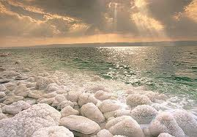

Dragon’s Well/Serpents Pool

Nehemiah 2:13 “And I went out by night by the gate of the valley, even before the dragon well, and to the dung port, and viewed the walls of Jerusalem, which were broken down, and the gates thereof were consumed with fire.” ^{KJV}

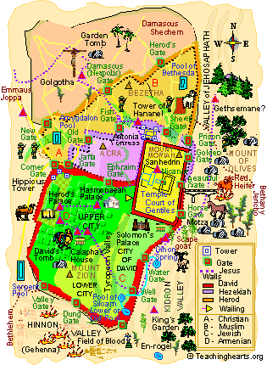
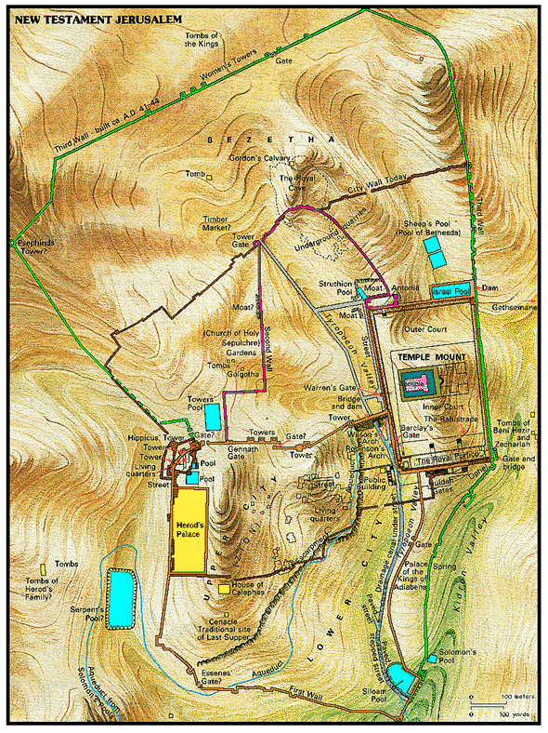

Potter’s Field

Matthew 27:3-10 “Then Judas, which had betrayed him, when he saw that he was condemned, repented himself, and brought again the thirty pieces of silver to the chief priests and elders, 4 Saying, I have sinned in that I have betrayed the innocent blood. And they said, What [is that] to us? see thou [to that]. 5 And he cast down the pieces of silver in the temple, and departed, and went and hanged himself. 6 And the chief priests took the silver pieces, and said, It is not lawful for to put them into the treasury, because it is the price of blood. 7 And they took counsel, and bought with them the potter's field, to bury strangers in. 8 Wherefore that field was called, The field of blood, unto this day. 9 Then was fulfilled that which was spoken by Jeremy the prophet, saying, And they took the thirty pieces of silver, the price of him that was valued, whom they of the children of Israel did value; 10 And gave them for the potter's field, as the Lord appointed me.” ^{KJV}

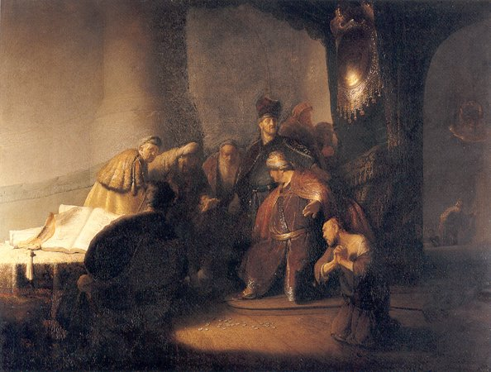
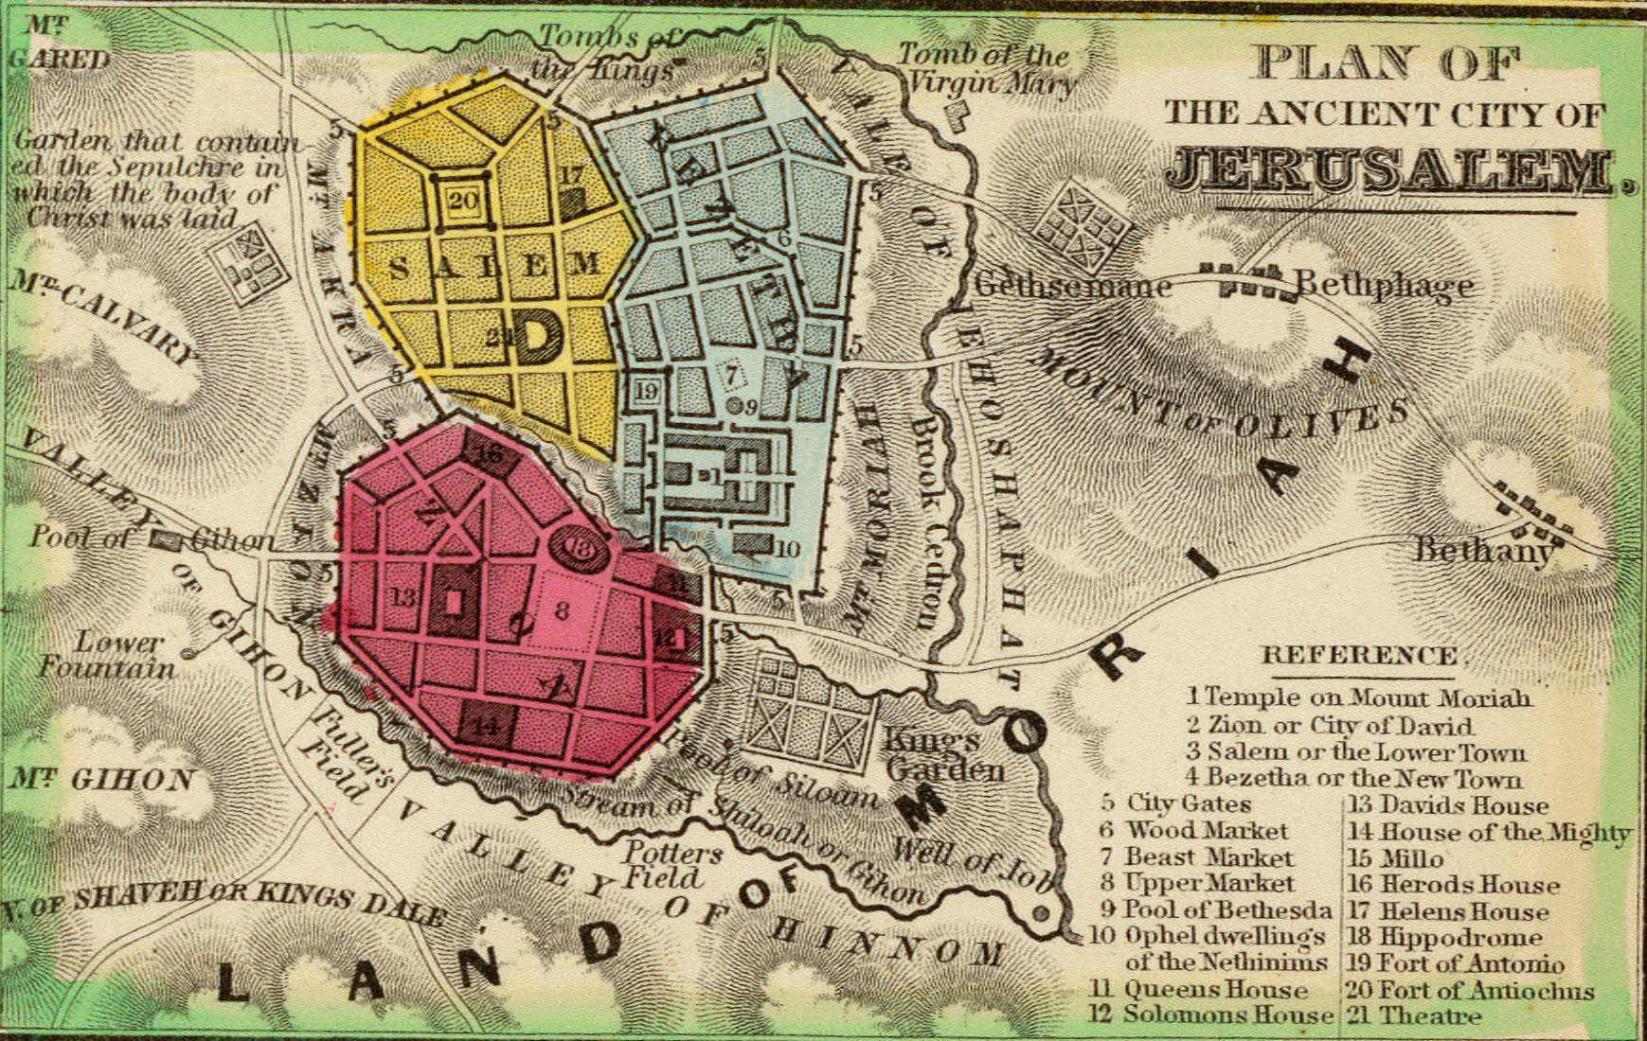

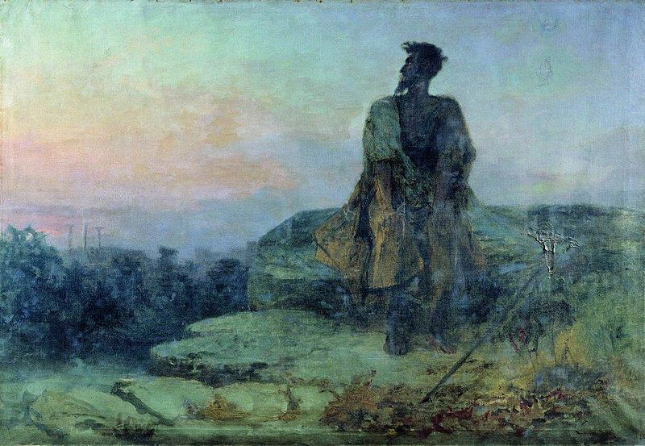

Paradise

Revelation 2:7 “He that hath an ear, let him hear what the Spirit saith unto the churches; To him that overcometh will I give to eat of the tree of life, which is in the midst of the paradise of God.” ^{KJV}

-a garden
-grand closures
-perserve
-park
-pleasure ground
-part of Hades which was thought by latter Jews to be the abode of the souls of the pious until resurrection
-region of the heavens
-place of which saints were resurrected from after cross
>Ezekiel 31

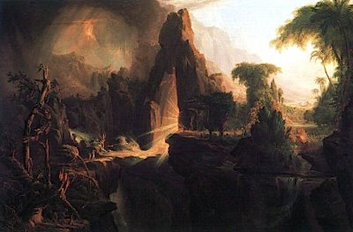

Forgotten Books of Eden: Adam & Eve 1:1-5 “On the third day, God planted the garden in the east of the earth, on the border of the world eastward, beyond which, towards the sun-rising, one finds nothing but water, that encompasses the whole world, and reaches unto the borders of heaven. 2 And to the north of the garden there is a sea of water, clear and pure to the taste, like unto nothing else; so that, through the clearness thereof, one may look into the depths of the earth, 3 And when a man washes himself in it, becomes clean of the cleanness thereof, and white of its whiteness- even if he were dark. 4 And God created that sea of His own good pleasure, for He knew what would come of the man He should make; so that after he had left the garden, on account of his transgression, men should be born in the earth, from among whom righteous ones should die, who souls God would raise at the last day; when they should return to their flesh; should bathe in the water of that sea, and all of them repent of their sins. 5 But when God made Adam go out of the garden, He did not place him on the border of it norhtward, lest he should draw near to the sea of water, and he and Eve wash themselves in it, be cleansed from their sins, forget the transgression they had committed, and be no longer reminded of it in the thought of their punishment.” Rutherford H. Platt Jr.

The Book of Jubilees 8:19a “And he knew that the Garden of Eden is the holy of holies, and the dwelling of the Lord.” ^{R.H. Charles}
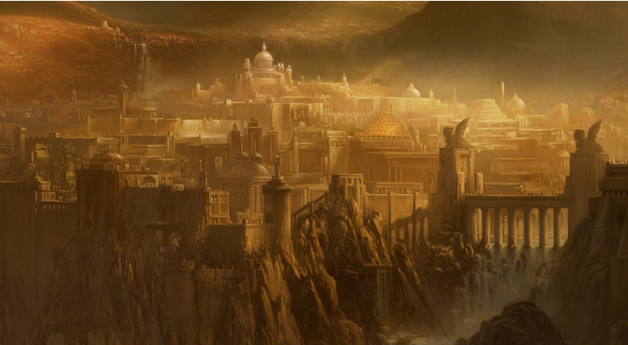
Edom

Geographic area between the Dead Sea and Red Sea

Isaiah 34:8-10 “For [it is] the day of the LORD's vengeance, The year of recompense for the cause of Zion. 9 Its streams shall be turned into pitch, And its dust into brimstone; Its land shall become burning pitch. 10 It shall not be quenched night or day; Its smoke shall ascend forever. From generation to generation it shall lie waste; No one shall pass through it forever and ever.” ^{NKJV}

13-15 ^{KJV} :dragons, wild beasts, satyrs will dwell there

14b ^{Living Bible}: There the night monsters will scream at each other and the demons will come there to rest.

1-14 ^{Brenton Septuagint} : proclaims it a resting place of monsters, satyrs, devils.

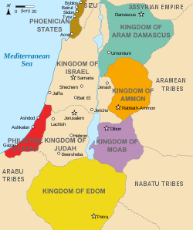
Zechariah 2:5 “For I, saith the LORD, will be unto her a wall of fire round about, and will be the glory in the midst of her.” ^{KJV}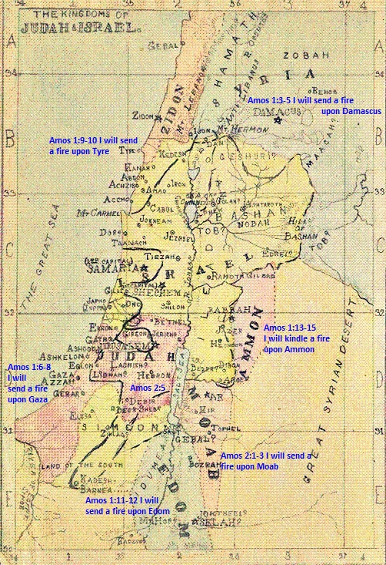

Transcendence/overview
Isaiah 40:22 “It is He who [fn]sits above the [fn]circle of the earth, And its inhabitants are like grasshoppers, Who stretches out the heavens like a curtain And spreads them out like a tent to dwell in.” ^{NASB}

descends from north
Job 37:22 “He comes from the north [as] golden [splendor]; With God [is] awesome majesty.” ^{NKJV (See also Isaiah 41:25)}

YHWH’S Reign
Micah 4:7 "I will make the lame a remnant And the outcasts a strong nation, And the LORD will reign over them in Mount Zion From now on and forever.” ^{NASB}

Joel 3:20-21 “But Judah will be inhabited forever And Jerusalem for all generations. 21 And I will avenge their blood which I have not avenged, For the LORD dwells in Zion.” ^{NASB}

Revelation 3:21 “To him that overcometh will I grant to sit with me in my throne, even as I also overcame, and am set down with my Father in his throne.” ^{KJV} (See also Psalm 16:11, 17:7)

Matthew 22:44 “The LORD said unto my Lord, Sit thou on my right hand, till I make thine enemies thy footstool?” ^{KJV}

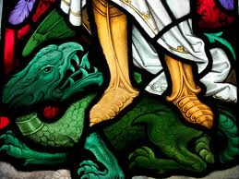

Malachi 4:2-3 “But unto you that fear my name shall the Sun of righteousness arise with healing in his wings; and ye shall go forth, and grow up as calves of the stall. 3 And ye shall tread down the wicked; for they shall be ashes under the soles of your feet in the day that I shall do [this], saith the LORD of hosts.” ^{KJV}

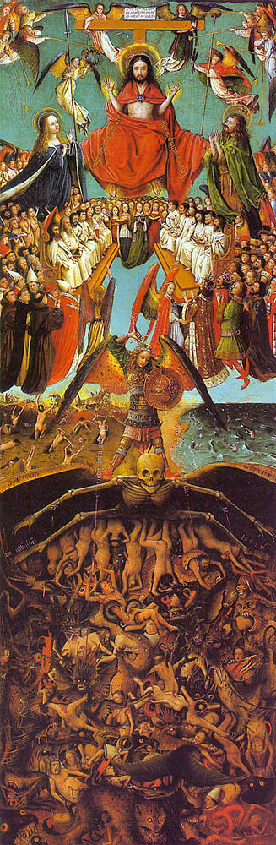
Isaiah 66:23-24
“And it shall be from new moon to new moon And from sabbath to sabbath, All mankind will come to bow down before Me," says the LORD. 24 "Then they will go forth and look On the corpses of the men Who have transgressed against Me. For their worm will not die And their fire will not be quenched; And they will be an abhorrence to all mankind." ^{NASB}
1 Enoch 27:2a-4 “This accursed valley is for those who are accursed for ever: here shall the accursed be gathered together who utter with their lips against the Lord unseemly words and of His glory speak hard things. Here shall they be gathered together, and here shall be their place of judgement. 3 In the last days there shall be upon them the spectacle of righteous judgement in the presence of the righteous for ever: here shall the merciful bless the Lord of Glory, the Eternal King.” ^{R.H. Charles}

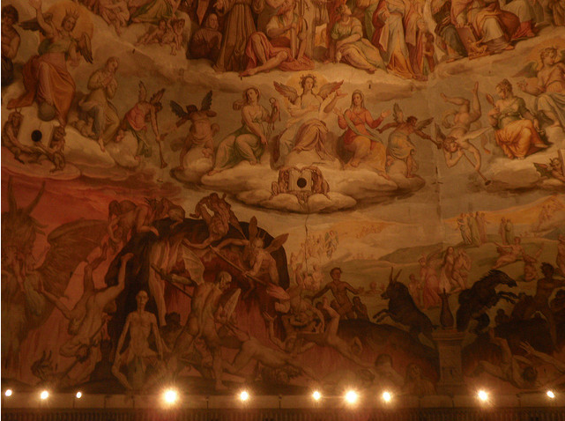

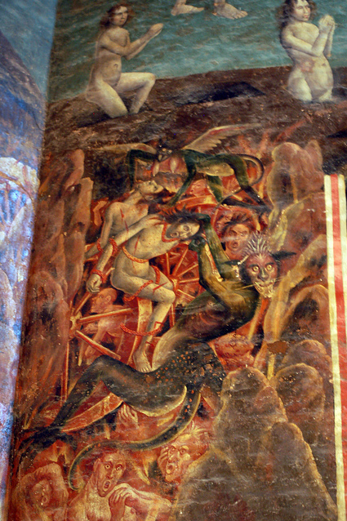
Isaiah 39:8-9 “Then shall the Assyrian fall with the sword, not of a mighty man; and the sword, not of a mean man, shall devour him: but he shall flee from the sword, and his young men shall be discomfited. 9 And he shall pass over to his strong hold for fear, and his princes shall be afraid of the ensign, saith the LORD, whose fire [is] in Zion, and his furnace in Jerusalem.” ^{KJV}

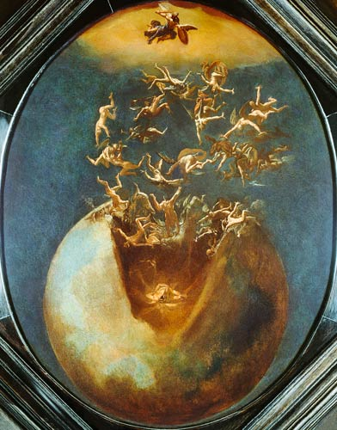

Matthew 13:50 “And shall cast them into the furnace of fire: there shall be wailing and gnashing of teeth.” ^{KJV}
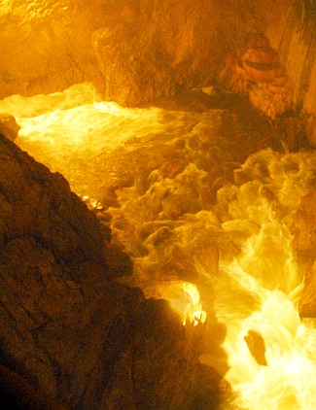

Revelation 20:14-15 “And death and hell were cast into the lake of fire. This is the second death. 15 And whosoever was not found written in the book of life was cast into the lake of fire.” ^{KJV}

*Revelation 19:20, 20:10
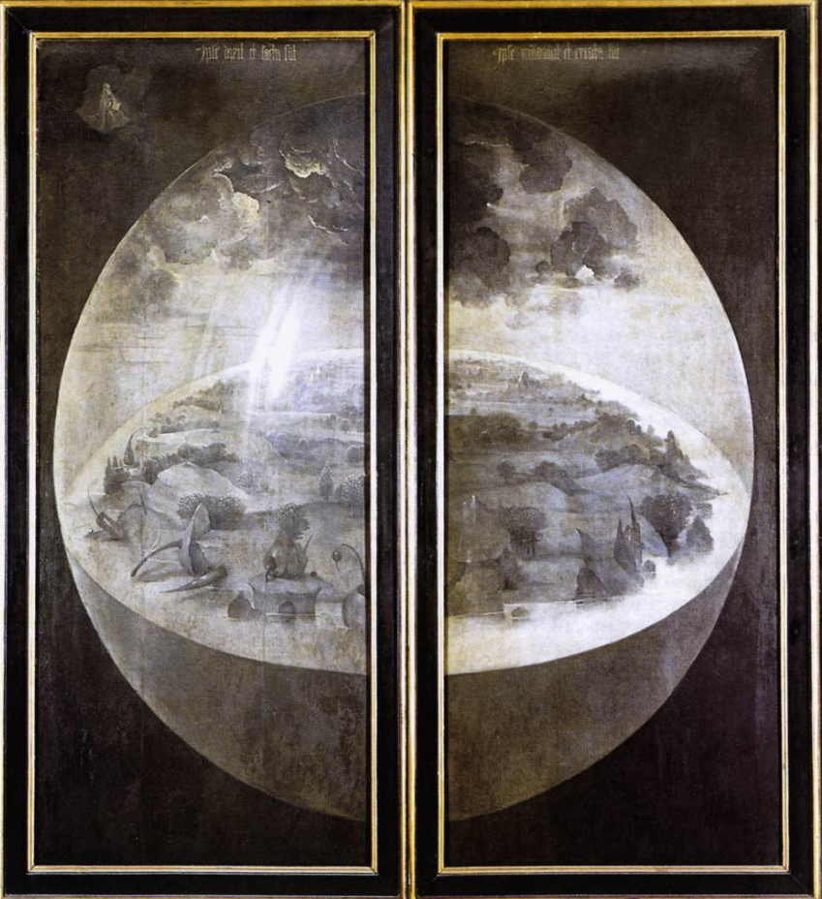

1 Samuel 28:7 “Then Saul said to his servants, "Seek for me a woman who is a medium, that I may go to her and inquire of her." And his servants said to him, "Behold, there is a woman who is a medium at En-dor. 11 Then the woman said, "Whom shall I bring up for you?" And he said, "Bring up Samuel for me." 12 When the woman saw Samuel, she cried out with a loud voice; and the woman spoke to Saul, saying, "Why have you deceived me? For you are Saul." 13 The king said to her, "Do not be afraid; but what do you see?" And the woman said to Saul, "I see a divine being coming up out of the earth." 14 He said to her, "What is his form?" And she said, "An old man is coming up, and he is wrapped with a robe." And Saul knew that it was Samuel, and he bowed with his face to the ground and did homage." ^{NASB}

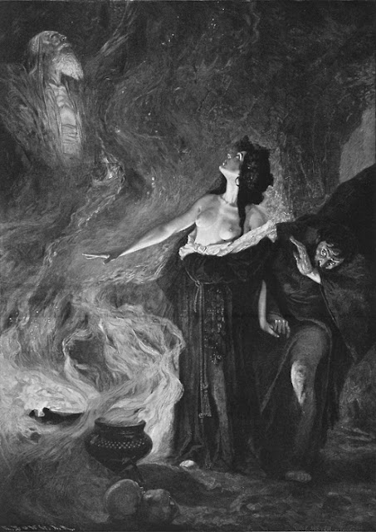
Adam

Forgotten books of eden: Adam & Eve 45:9-12 “God said also to Adam, “See this fire kindled by Satan around thy cave; see this wonder that surrounds thee; and know that it will encompass about both thee and thy seed, when ye hearken to his behest; hthat he will plague you with fire; and that ye shall go down into hell after ye are dead. 10 “Then shall ye see the burning of his fire, that will thus be burning around you and your seed. There shall be no deliverance from it for you, but as My coming; in like manner as thou canst not now go into thy cave, by reeason of the great fire around it; not until My Word shall come that will make a way for thee on the day My covenant is fulfilled. 11 “There is no way for thee at present to come from hence to rest, not until My word comes, who is My Word. Then will He make a way for thee, and thou shalt have rest.” Then God called with His Word to that fire that burned around the cave, that it part itself asunder, until Adam had gone through it. Then the fire parted itself by God’s order, and a way was made for Adam. 12 And God withdrew His Word from Adam.”
^{Rutherford H. Platt Jr.}

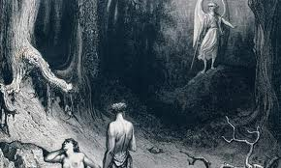
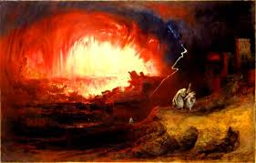

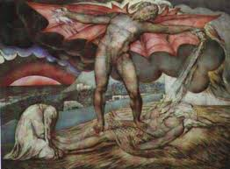

JONAH

Jonah 2 “And from out of the belly of the great whale, Jonas prayed to the Lord his God, 2 and said: In my great affliction I cried to the Lord of my God, and He hearkened to me. Thou didst hear my cry from the womb of Hades, thou didst hearken to my prayer; 3 Thou hast cast me into the depths of the heart of the sea. When streams encompassed me- all Thy billiows and Thy waves passed over me. 4 Then I said, I am cast out from Thy sight;nevertheless I will continue to look towards Thy holy temple. 5 The water was poured around me to my soul, and the lowest abyss encompassed me; my head hath goen down into the clefts of the mountains. 6 I have gone down to aland, the bars of which are everlastingly fixed. Let my soul now, corrupted as it is, ascent, O Lord, my God. 7 When my soul was fainting I remember the Lord; let my prayer now come to Thee into Thy holy temple. 8 They who worship vanities and lies have forsaken their mercy. 9 but I will sacrifice to Thee with the voice of praise and thanksgiving. I will pay Thee what I have vowed to the Lord for my deliverance. 10 Upon this a command was given by the Lord to the whale, and it cast forth Jonas upon the dry ground.” ^{Brenton Septuagint}

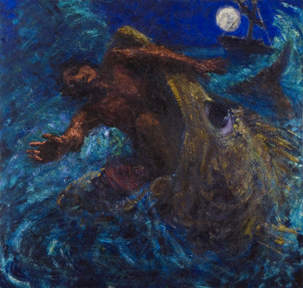
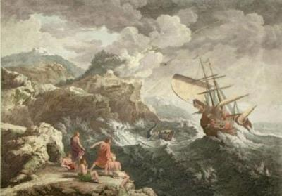

JOB

Job 38:16-17 “Hast thou entered into the springs of the sea? or hast thou walked in the search of the depth? 17 Have the gates of death been opened unto thee? or hast thou seen the doors of the shadow of death?” ^{NASB}

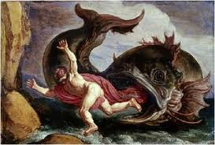
CHRIST

Matthew 12:40 “For as Jonas was three days and three nights in the whale's belly; so shall the Son of man be three days and three nights in the heart of the earth.” ^{KJV}

Gospel of Nicodemus 17 “Impious Death and her cruel officers hearing these things, were serized with fear in their several kingdoms, hen they shaw the clearness of the light, 2 And Christ himself on a sudden appearing in their habitations; they cried out therefore, and said, We are bound by thee; thou seemest to intend our confusion before the Lord. 3 Who are thou, who hast no sign of corruption, but that bright appearance which is a full proof of thy greatness, of which yet thou seemest to take no notice? 4 Who are thou, so powerful and so weak, so great and so little, a mean and yet a solider of the first rank, who can command in the form of a servant as a common solider? 5 The King of Glory, dead and alive, though once slain upon the cross? 6 Who layest dead in the grave, and art come down alive to us, and in thy death all the ceratures trembled, and all the stars were moved, and now hast thou thy liberty among the dead, and givest disturbance to our legions? 7 Who are thou, who dost release the captives that were held in chains by original sin, and bringest them into their former liberty? 8 Who art thou, who dost spread so glorious and divine a light over those who were made blind by the darkness of sin? 9 In like manner all the legions of devils were seized with the like horror, and with the most submissive fear cried out, and said, 10 Whence comes it, O thou Jesus Christ, that thou art a man so powerful and glorious in majesty, so bright as to have no spot, and so pure as to have no crime? For that lower world of earth, which was ever till not subject to us, and from whence we received tribute, never sent us such a dead man before, never sent such a presents as these to the princes of hell. 11 Who therefore art thou, who with such courage enterest among our abodes, and art not only not afraid to threaten us with the greatest punishments, but also endeavourest to rescue all others from the chains in which we hold them? 12 Perhaps thou art that Jesus, of who Satan, just now spoke to our princes, that by the death of the cross thou wert aboce to receive the power of death. 13 Then the King of Glory trampling upon death, seized the princes of hell, deprived him of all his power, and took our earthly father Adam with him to his glory.” ^{Rutherford H. Platt Jr.}

The Apostle’s Creed 1-6 United Church of England and Ireland as by the law established
“I believe in God the Father Almight, maker of heaven and earth: 2 And in Jesus Christ his only Son, our Lord: 3 Who was conceived by the Holy Ghost, born of the Virgin Mary, 4 Suffered under Pontius Pilate, was crucified, dead and buried; 5 He descended into hell; 6 The third day he rose again from the dead;” ^{Rutherford H. Platt Jr.}
Living Descent into Hades

1 Enoch 51:8 “In those days Sheol shall open its jaws, And they shall be swallowed up therein, And their destruction shall be at an end; Sheol shall devour the sinners in the presence of the elect.” ^{R H. Charles}
see also Isaiah 5:14
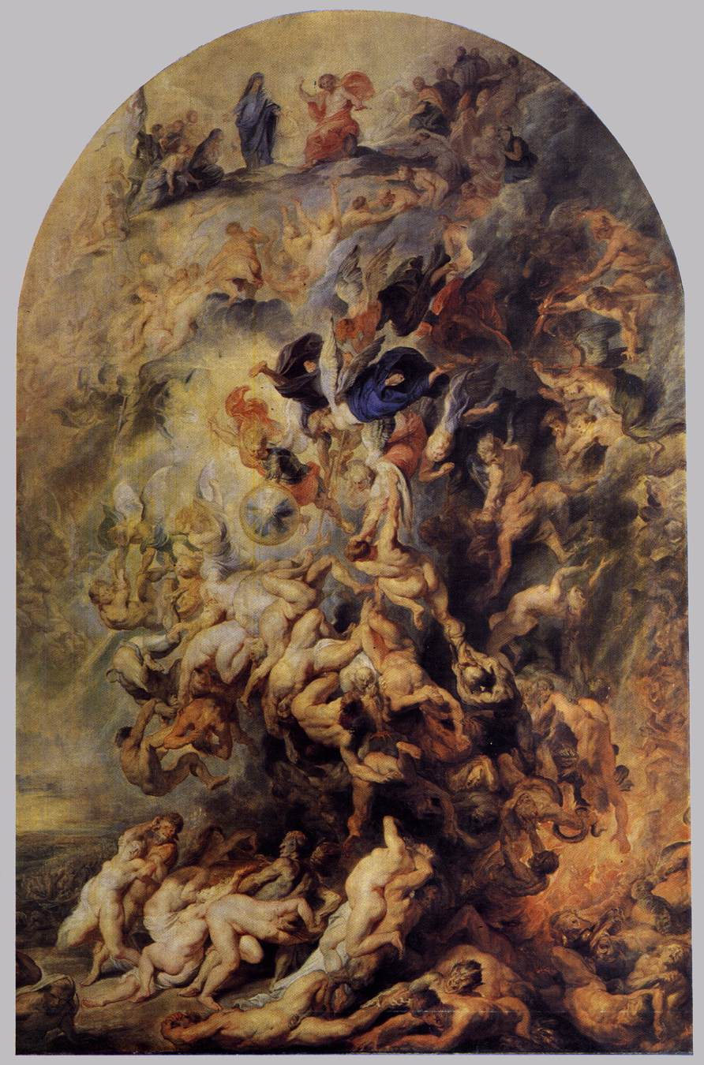
Psalms 55:15 “Let death seize upon them, [and] let them go down quick into hell (hades- Septuagint): for wickedness [is] in their dwellings, [and] among them.” ^{KJV}
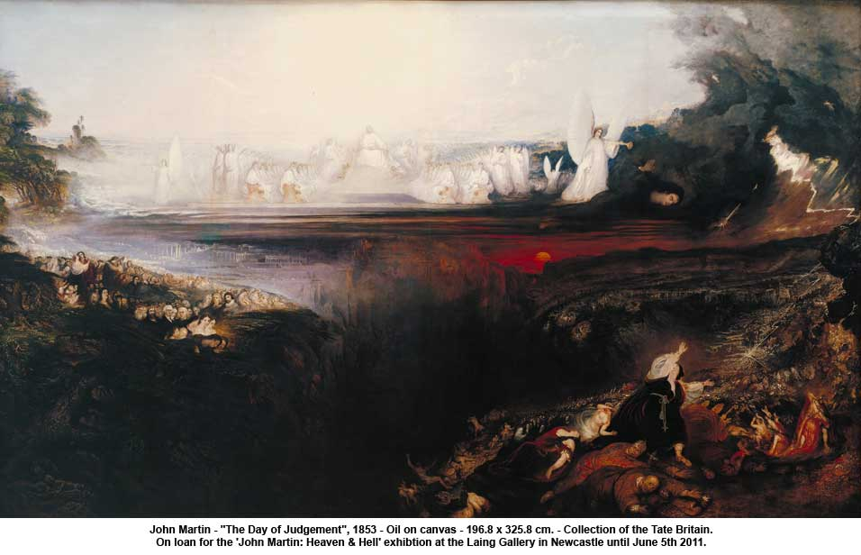
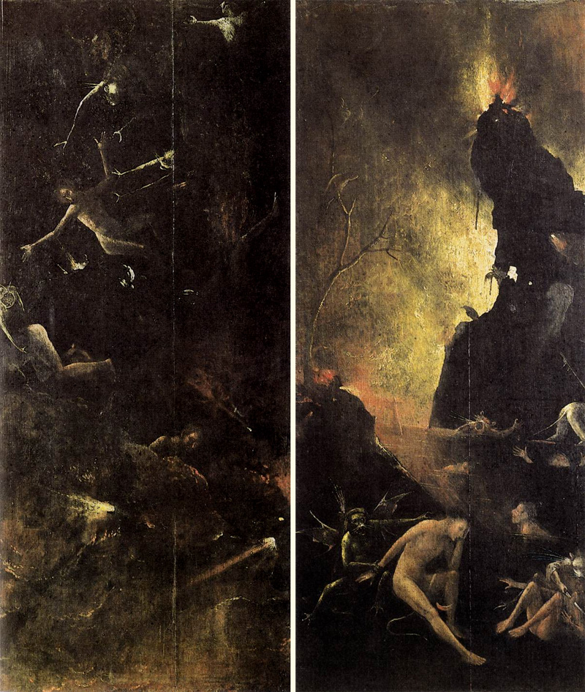
Korah

Numbers 16:28-34 “Moses said, "By this you shall know that the LORD has sent me to do all these deeds; for this is not [fn]my doing. 29 "If these men die the death of all men or if they suffer the fate of all men, then the LORD has not sent me. 30 "But if the LORD brings about an entirely new thing and the ground opens its mouth and swallows them up with all that is theirs, and they descend alive into Sheol, then you will understand that these men have spurned the LORD." 31 As he finished speaking all these words, the ground that was under them split open; 32 and the earth opened its mouth and swallowed them up, and their households, and all the men who belonged to Korah with their possessions. 33 So they and all that belonged to them went down alive to Sheol; and the earth closed over them, and they perished from the midst of the assembly. 34 All Israel who were around them fled at theiroutcry, for they said, "The earth may swallow us up!" ^{NASB}

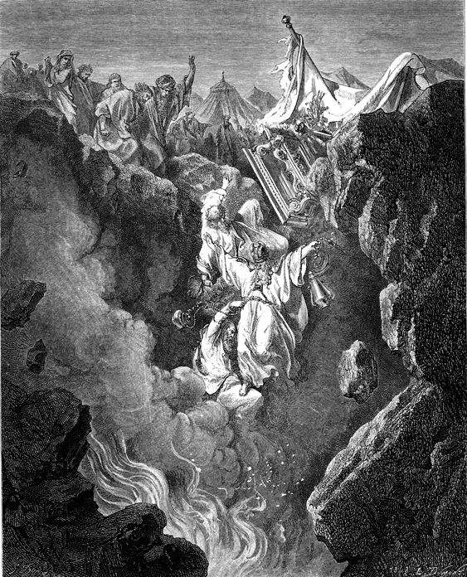

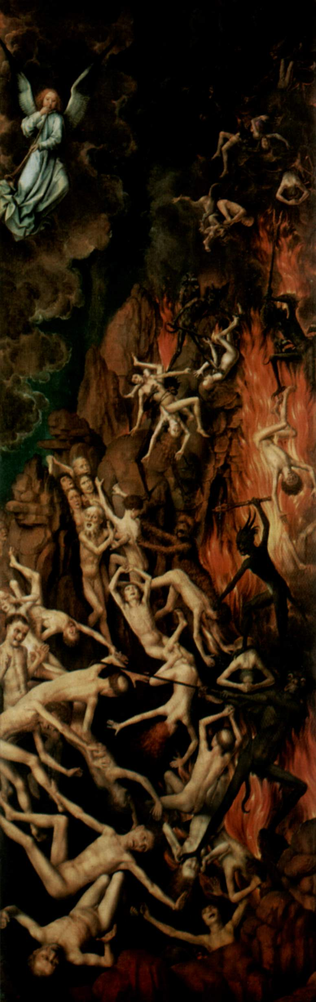
Ezekiel 28:6-10 “Therefore thus saith the Lord GOD; Because thou hast set thine heart as the heart of God; 7 Behold, therefore I will bring strangers upon thee, the terrible of the nations: and they shall draw their swords against the beauty of thy wisdom, and they shall defile thy brightness. 8 They shall bring thee down to the pit, and thou shalt die the deaths of [them that are] slain in the midst of the seas. 9 Wilt thou yet say before him that slayeth thee, I [am] God? but thou [shalt be] a man, and no God, in the hand of him that slayeth thee. 10 Thou shalt die the deaths of the uncircumcised by the hand of strangers: for I have spoken [it], saith the Lord GOD.
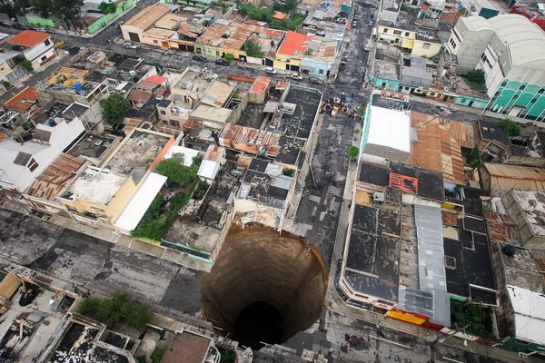

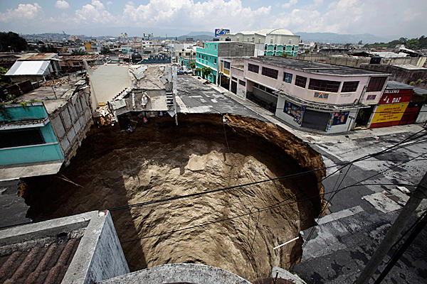

1 Enoch 1:1, 6-7 “1 The words of the blessing of Enoch, wherewith h blessed the elect and, righteous who will be living in the day of tribulation, when all the wicked and godless are to be removed. 6 And the higher mountains shall be shaken, And the high hills shall be made low. And shall melt like wax before the flame 7 And the earth shall be wholly rent in sunder And all that is upon the earth shally perish. And there shall be a judgement upon all (men).” ^{R.H. Charles}
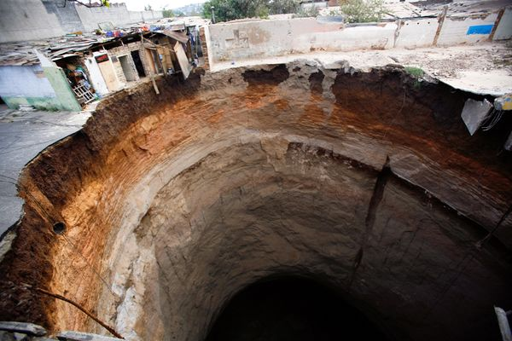

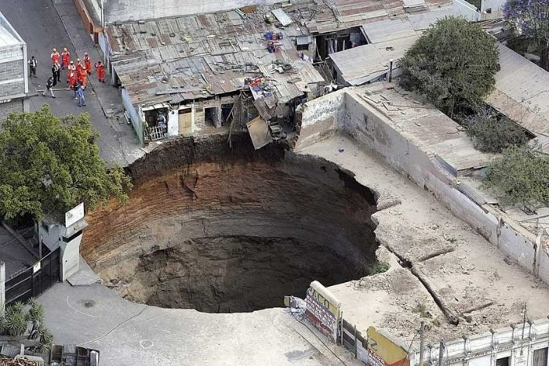
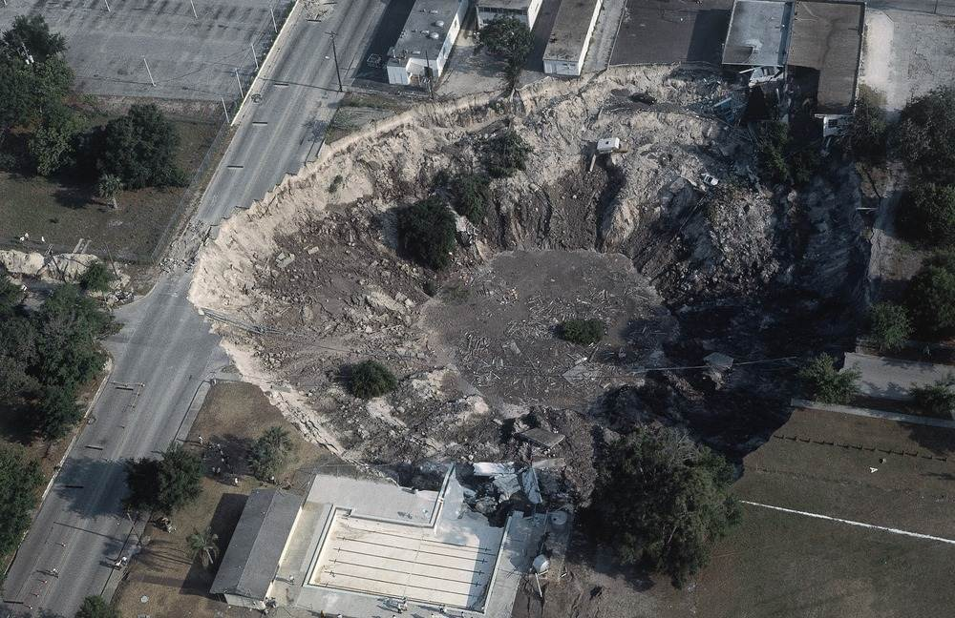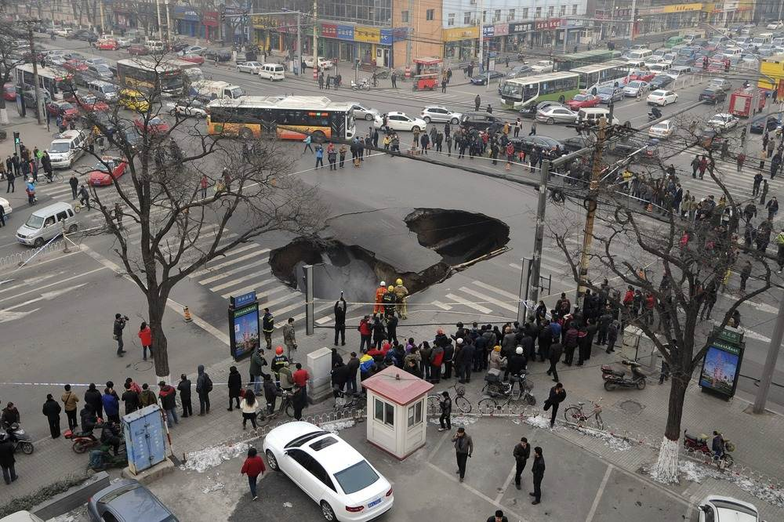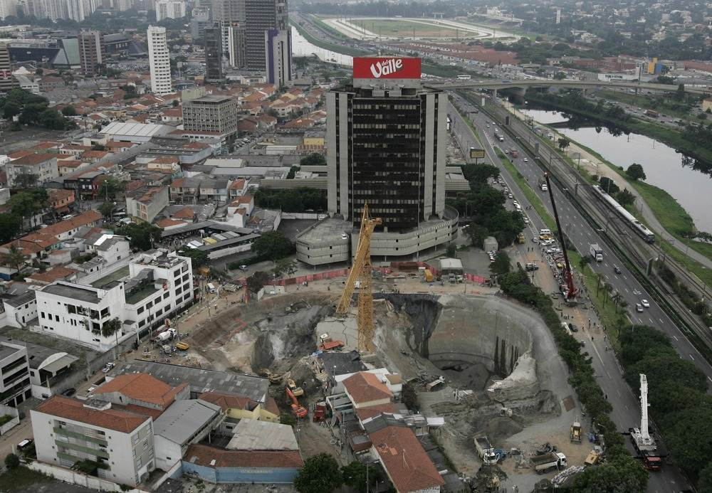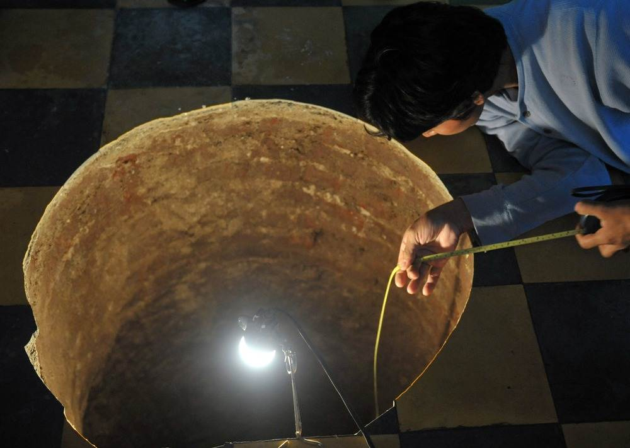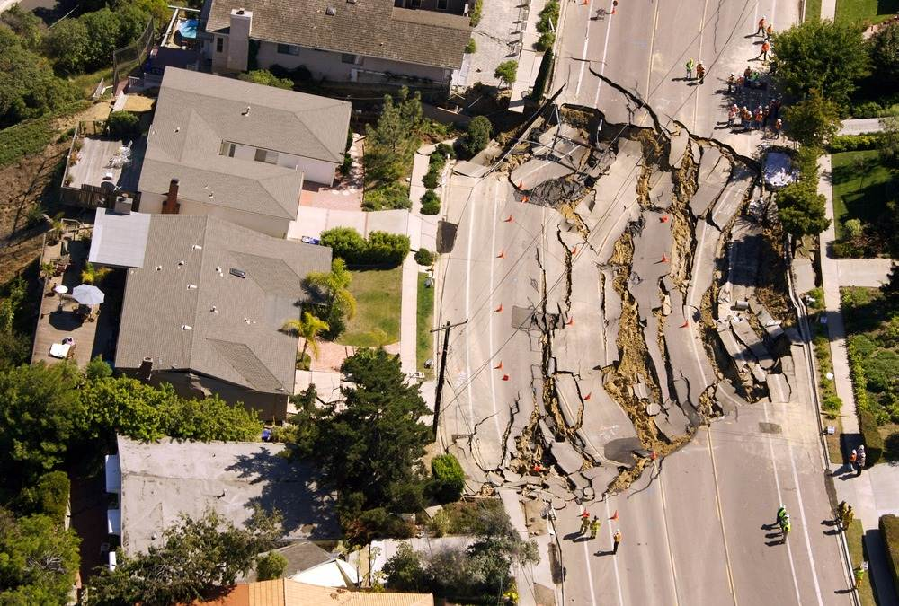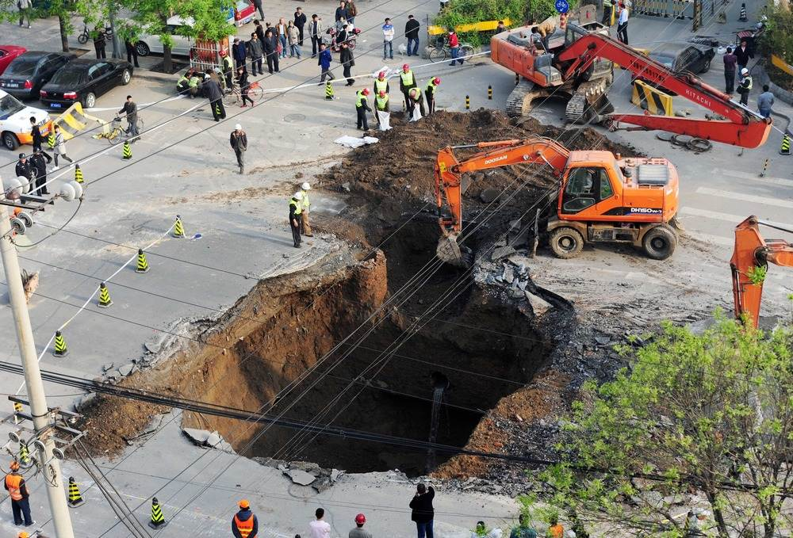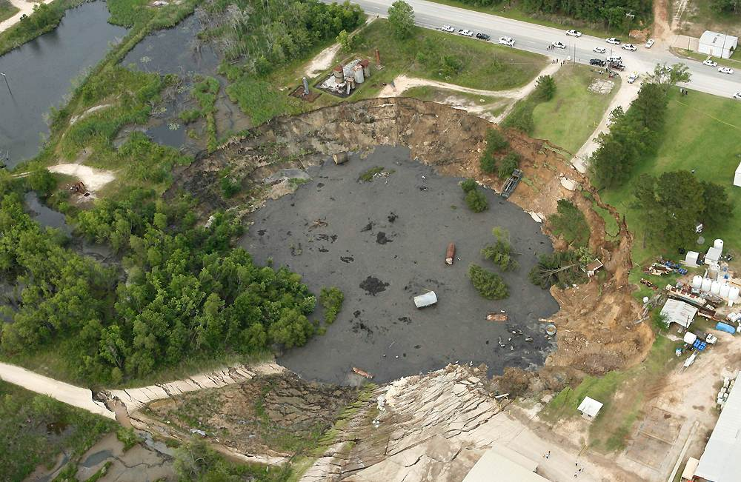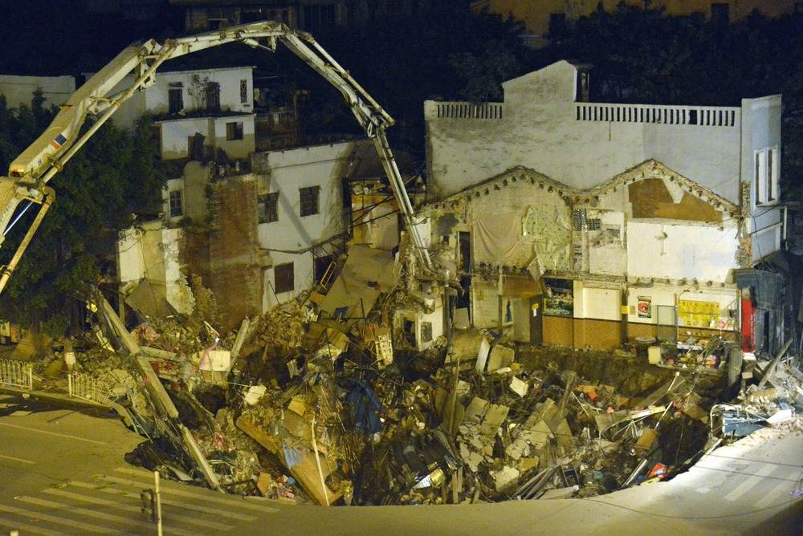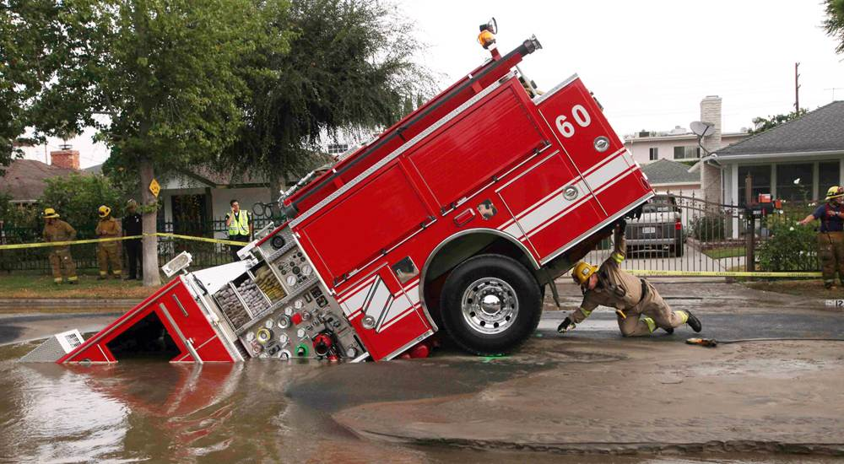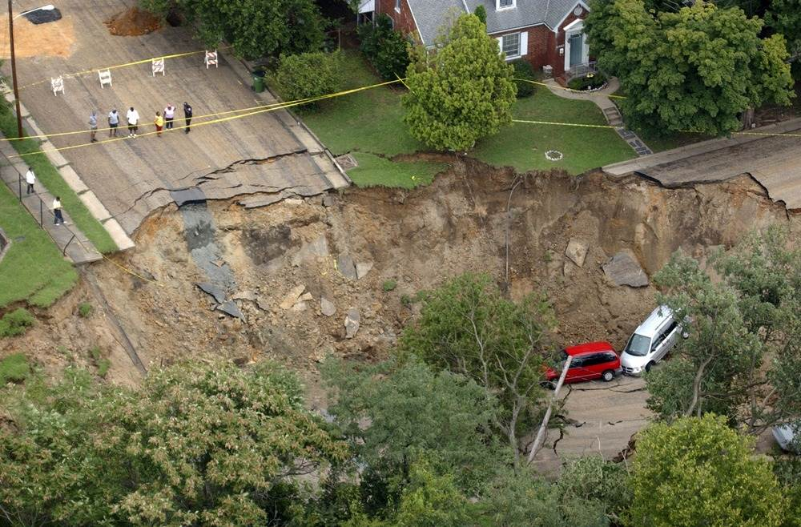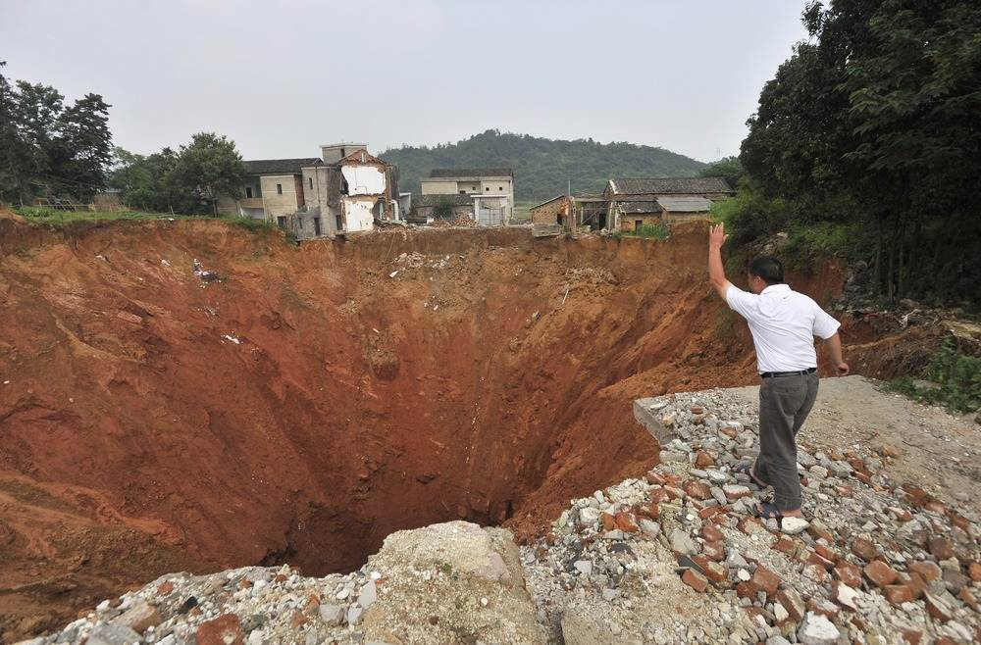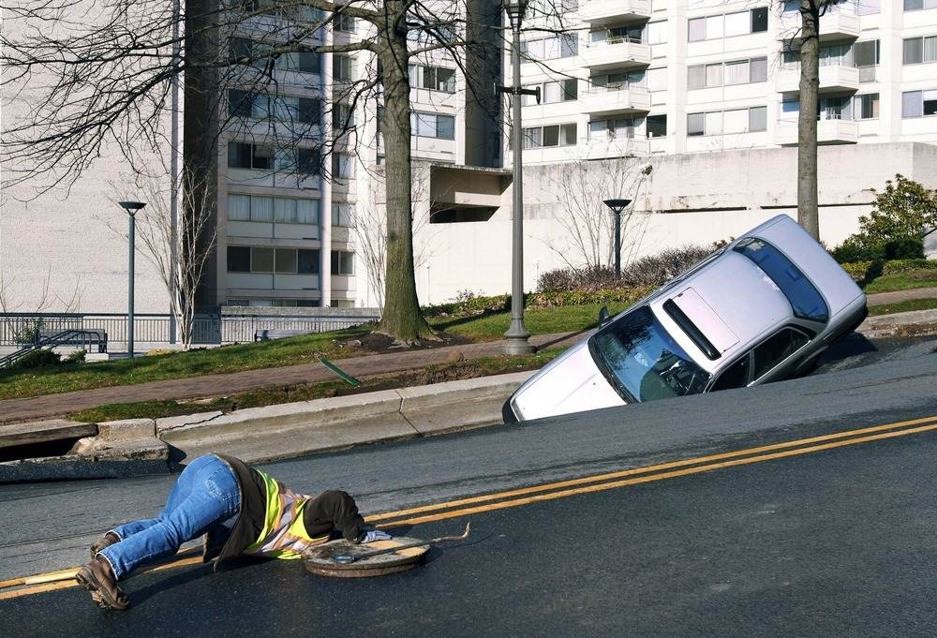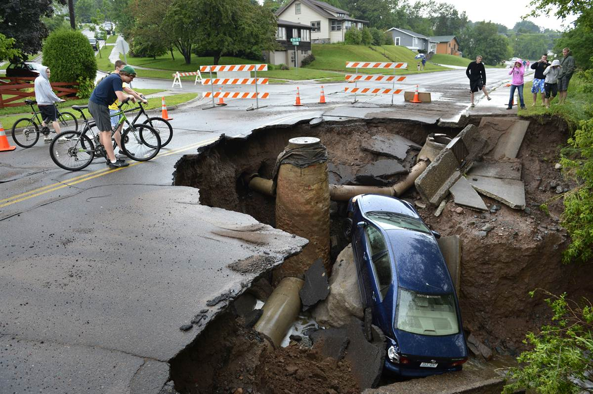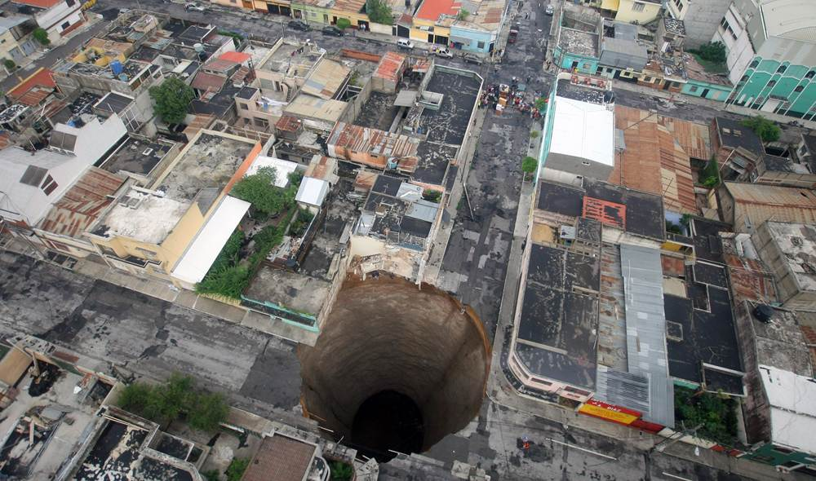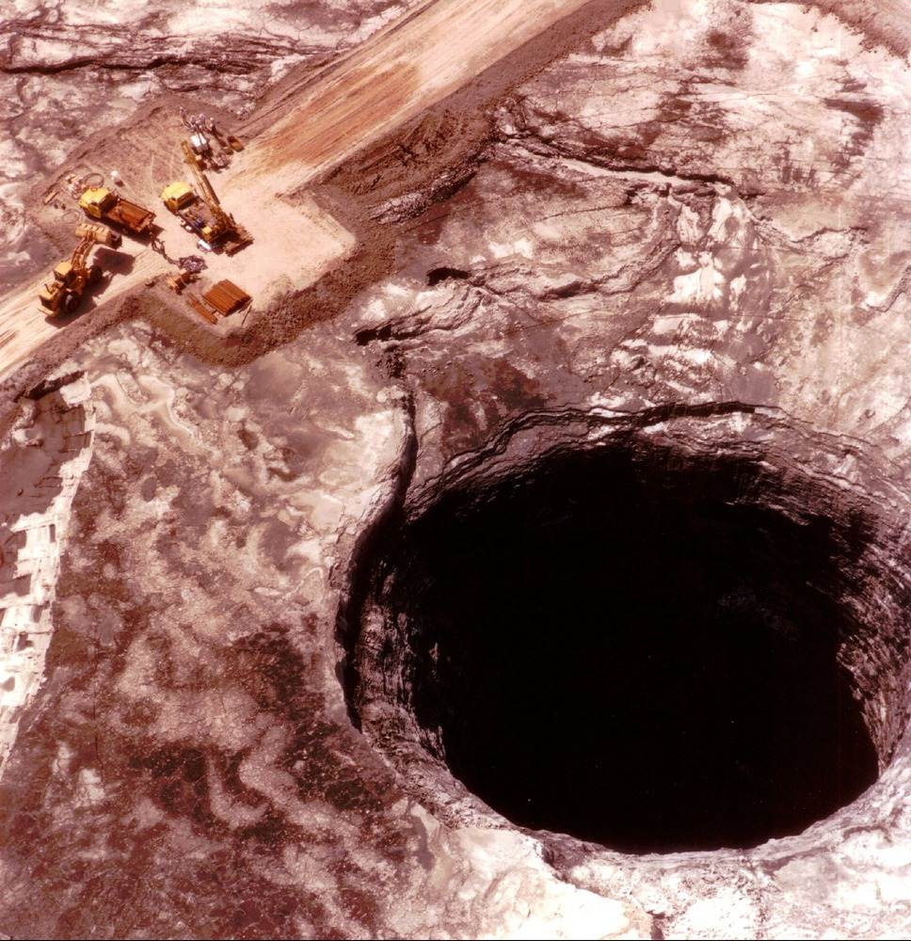

 | Exd 15:12 |  | Thou stretchedst out ⁵¹⁸⁶ thy right hand ³²²⁵, the earth ⁷⁷⁶ swallowed ¹¹⁰⁴ them.

1 Enoch 83:3-9 “I had laid me down in the house of my grandfather Mahalalel, (when) I saw in a vision how they heaven collapsed and was borne off and fell to the earth. 4 And when it fell to the earth I saw how the earth was swallowed up in a great abyss, and mountains were suspended on mountains, and hills sank down on hills, and high trees were rent from their stems, and hurled down and sunk in the abyss. 5 And thereupon a word fell into my mouth, and I lifted up (my voice) to cry aloud, and said: ‘The earth is destroyed.’ 6 And my grandfather Mahalalel waked me as I lay near him, and said unto me: ‘Why dost thou cry so, my son, and why dost thou make such lamentation?’ 7 And I recounted to him the whole cision which I had seen, and he said unto me: ‘A terrbiel thing has thou seen, my son, and of grave moment is thy dream-vision as to the secrets of all sin of the earth: it must sink into the abyss and be destroyed with a great destruction. 8 And now, my son, arise and make petition to the Lord of glory, since thou art a believer, that a remnant may remain on the earth, and that He may not destroy the whole earth. 9 My son, from heaven all this will come upon the earth, and upon the earth there will be great destruction.” ^{R.H. Charles}

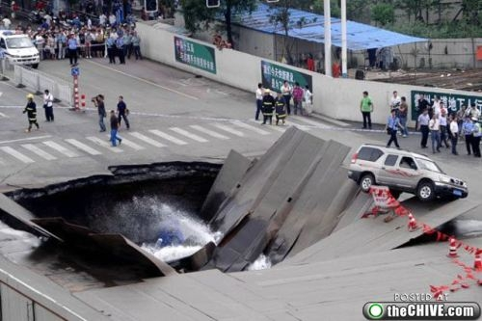

Revelation 12:15-16 “And the serpent cast out of his mouth water as a flood after the woman, that he might cause her to be carried away of the flood. 16 And the earth helped the woman, and the earth opened her mouth, and swallowed up the flood which the dragon cast out of his mouth.” ^{KJV}

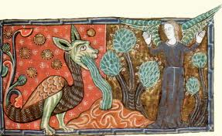

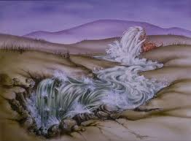

Psalm 18:3-5 “I will call upon the LORD, [who is worthy] to be praised: so shall I be saved from mine enemies. 4 The sorrows of death compassed me, and the floods of ungodly men made me afraid. 5 The sorrows of hell compassed me about: the snares of death prevented me.” ^{KJV}
See also Psalm 69:1-4. Jeremiah 46:7-8, 47:2
Loosing of the Underworld

Revelation 9:1-3 “And the fifth angel sounded, and I saw a star fall from heaven unto the earth: and to him was given the key of the bottomless pit. 2 And he opened the bottomless pit; and there arose a smoke out of the pit, as the smoke of a great furnace; and the sun and the air were darkened by reason of the smoke of the pit. 3 And there came out of the smoke locusts upon the earth: and unto them was given power, as the scorpions of the earth have power.” ^{KJV}

Revelation 9:14-15 “Saying to the sixth angel which had the trumpet, Loose the four angels which are bound in the great river Euphrates. 15 And the four angels were loosed, which were prepared for an hour, and a day, and a month, and a year, for to slay the third part of men.” ^{KJV}

Revelation 20:7-8 “When the thousand years are completed, Satan will be released from his prison, 8 and will come out to deceive the nations which are in the four corners of the earth, Gog and Magog, to gather them together for the war; the number of them is like the sand of the seashore.” ^{NASB}
(See also Rev. 20:1-3)

Job 37:17-18 “Have the gates of death been revealed to you, Or have you seen the gates of deep darkness? 18 "Have you understood the expanse of the earth? Tell Me, if you know all this.” ^{NASB}
Isaiah 60:1 “For behold, darkness will cover the earth And deep darkness the peoples; But the LORD will rise upon you And His glory will appear upon you.” ^{NASB}

Gopsel of Nicodemus 16:19 *Of Christ’s descent to Hell* “And broke asunder the fetters which before could not be broken; and with his invincible power visited those who sate in the deep darkness by iniquity, and the shadow of death by sin.”

Revelation 6:8 “And I looked, and behold a pale horse: and his name that sat on him was Death, and Hell followed with him. And power was given unto them over the fourth part of the earth, to kill with sword, and with hunger, and with death, and with the beasts of the earth.” ^{KJV} | Revelation 6:8 “I looked, and behold, an ashen horse; and he who sat on it had the name Death; and Hades was following with him. Authority was given to them over a fourth of the earth, to kill with sword and with famine and with pestilence and by the wild beasts of the earth.” ^{NASB} | Revelation 6:8 “And I saw, and consider this, a pallid horse, greenish-yellow in colour. And the one who is seated upon it was named The Death. And the Unseen kept on following with him. And there was given to them authority over one fourth of the earth, to kill with the sword and with famine and with pestilence and by means of the wild beats of the earth.” ^{Wuest Expanded Translation}
Isaiah 2:19 “And they shall go into the holes of the rocks, and into the caves of the earth, for fear of the LORD, and for the glory of his majesty, when he ariseth to shake terribly the earth.” ^{KJV}

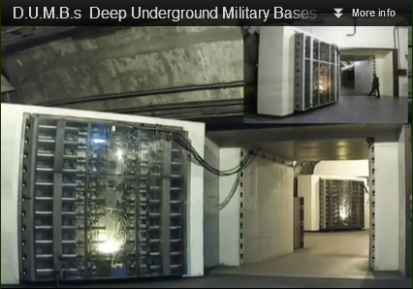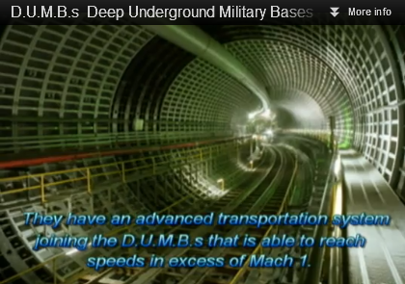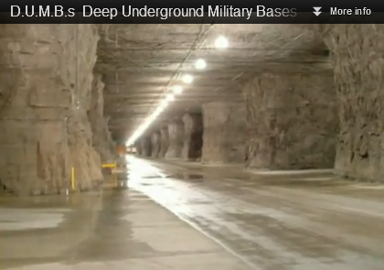
Amos 9:3b “and though they be hid from my sight in the bottom of the sea, thence will I command the serpent (nachash), and he shall bite (Nashak:vex/oppress) them:” ^{KJV}

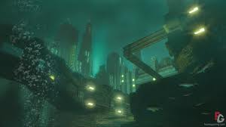

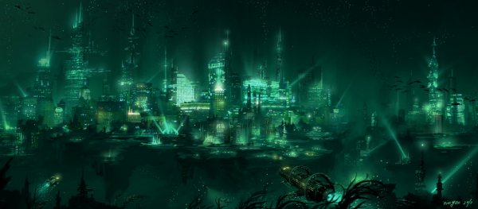

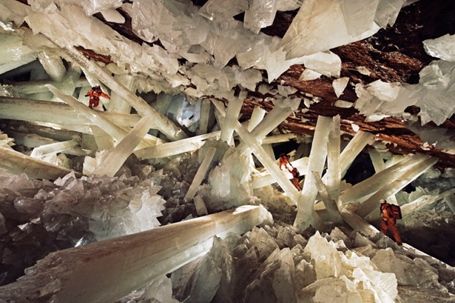

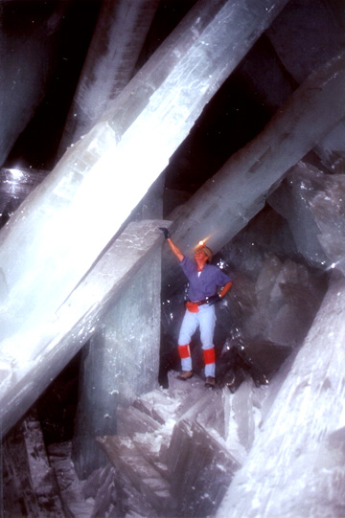

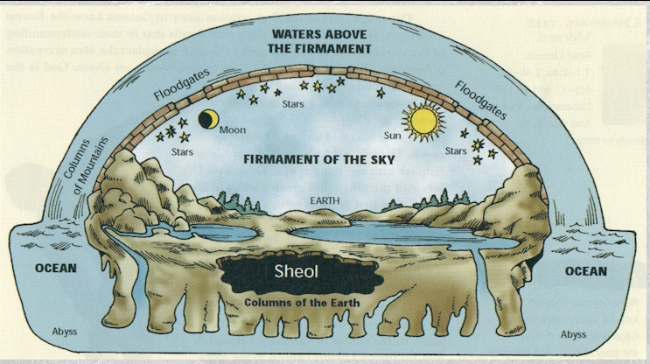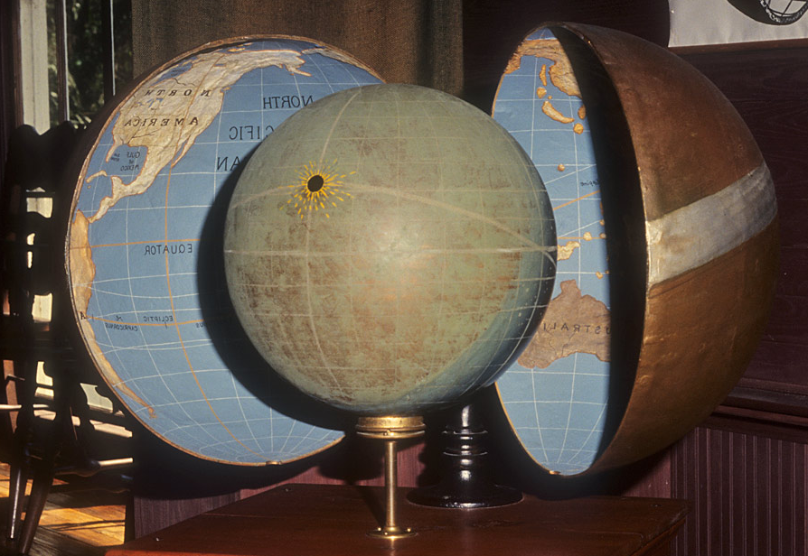

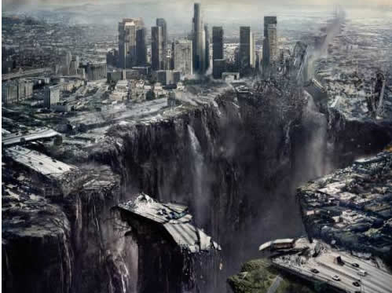
http://ve3d.ign.com/videos/51133/Wireless/2012-The-Mobile-Game/Trailer/2012-Movie-Trailer-2

