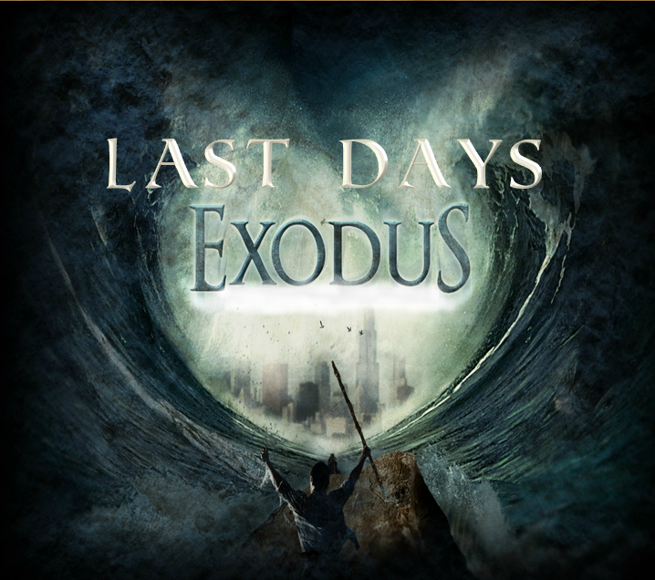

Isaiah 11:11-12, 15, 16

_{KJV}
“And it shall come to pass in that day, [that] the Lord shall set his hand again the second time to recover the remnant of his people, which shall be left, from Assyria, and from Egypt, and from Pathros, and from Cush, and from Elam, and from Shinar, and from Hamath, and from the islands of the sea.12 And he shall set up an ensign for the nations, and shall assemble the outcasts of Israel, and gather together the dispersed of Judah from the four corners of the earth.15 And the LORD shall utterly destroy the tongue of the Egyptian sea; and with his mighty wind shall he shake his hand over the river, and shall smite it in the seven streams, and make [men] go over dryshod.16 And there shall be an highway for the remnant of his people, which shall be left, from Assyria; like as it was to Israel in the day that he came up out of the land of Egypt.”
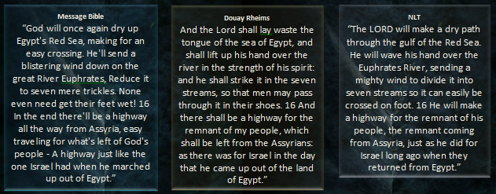
Zechariah 10:10-11 “And I will bring them again from the land of Egypt, and I will gather them in from among the Assyrians; and I will bring them into the land of Galaad and to Libanus; and there shall not even one of them be left behind. 11 And they shall pass through a narrow sea, they shall smite the waves in the sea, and all the deep places of the rivers shall be dried up: and all the pride of the Assyrians shall be taken away, and the sceptre of Egypt shall be removed” ^{Brenton Septuagint}

Isaiah 19:23-24 “In that day shall there be a highway out of Egypt to Assyria, and the Assyrian shall come into Egypt, and the Egyptian into Assyria, and the Egyptians shall serve with the Assyrians. 24 In that day shall Israel be the third with Egypt and with Assyria, [even] a blessing in the midst of the land:” ^{KJV}

Isaiah 27:13, Micah 7:12

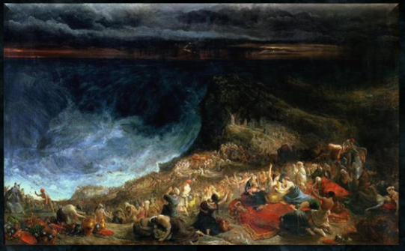

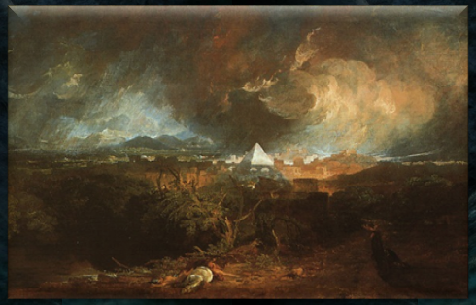

Micah 7:15-17 “As in the days when you came out of the land of Egypt, I will show them] wonders.16 The nations shall see and be ashamed of all their might; They shall put [their] hand over [their] mouth;Their ears shall be deaf.17 They shall lick the dust like a serpent;They shall crawl from their holes like snakes of the earth. They shall be afraid of the LORD our God, And shall fear because of You.” ^{NKJV}

2 Esdras 15:1-27 “1 Speak in the ears of my people the words of the prophecy that I will put in your mouth, says the Lord, 2 and cause them to be written on paper; for they are trustworthy and true. 3 Do not fear the plots against you, and do not be troubled by the unbelief of those who oppose you. 4 For all unbelievers shall die in their unbelief. 5 Beware, says the Lord, I am bringing evils upon the world, the sword and famine, death and destruction, 6 because iniquity has spread throughout every land, and their harmful doings have reached their limit. 7 Therefore, says the Lord, 8 I will be silent no longer concerning their ungodly acts that they impiously commit, neither will I tolerate their wicked practices. Innocent and righteous blood cries out to me, and the souls of the righteous cry out continually. 9 I will surely avenge them, says the Lord, and will receive to myself all the innocent blood from among them. 10 See, my people are being led like a flock to the slaughter; I will not allow them to live any longer in the land of Egypt, 11 but I will bring them out with a mighty hand and with an uplifted arm, and will strike Egypt with plagues, as before, and will destroy all its land. 12 Let Egypt mourn, and its foundations, because of the plague of chastisement and castigation that the Lord will bring upon it. 13 Let the farmers that till the ground mourn, because their seed shall fail to grow and their trees shall be ruined by blight and hail and by a terrible tempest. 14 Alas for the world and for those who live in it! 15 For the sword and misery draw near them, and nation shall rise up to fight against nation, with swords in their hands. 16 For there shall be unrest among people; growing strong against one another, they shall in their might have no respect for their king or the chief of their leaders. 17 For a person will desire to go into a city, and shall not be able to do so. 18 Because of their pride the cities shall be in confusion, the houses shall be destroyed, and people shall be afraid. 19 People shall have no pity for their neighbors, but shall make an assault upon their houses with the sword, and plunder their goods, because of hunger for bread and because of great tribulation. 20 See how I am calling together all the kings of the earth to turn to me, says God, from the rising sun and from the south, from the east and from Lebanon; to turn and repay what they have given them. 21 Just as they have done to my elect until this day, so I will do, and will repay into their bosom. Thus says the Lord God: 22 My right hand will not spare the sinners, and my sword will not cease from those who shed innocent blood on earth. 23 And a fire went forth from his wrath, and consumed the foundations of the earth and the sinners, like burnt straw. 24 Alas for those who sin and do not observe my commandments, says the Lord; 25 I will not spare them. Depart, you faithless children! Do not pollute my sanctuary. 26 For God knows all who sin against him; therefore he will hand them over to death and slaughter. 27 Already calamities have come upon the whole earth, and you shall remain in them; God will not deliver you, because you have sinned against him.” ^{NRSV}

Revelation 12:6 “And the woman fled into the wilderness, where she hath a place prepared of God, that they should feed her there a thousand two hundred [and] threescore days.” ^{KJV}

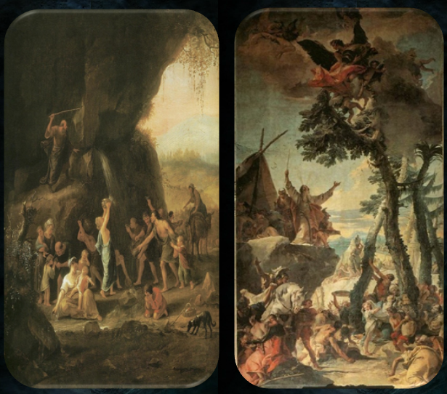

Revelation 12:13-17 “And when the dragon saw that he was cast unto the earth, he persecuted the woman which brought forth the man [child].14 And to the woman were given two wings of a great eagle, that she might fly into the wilderness, into her place, where she is nourished for a time, and times, and half a time, from the face of the serpent. 15 And the serpent cast out of his mouth water as a flood after the woman, that he might cause her to be carried away of the flood. 16 And the earth helped the woman, and the earth opened her mouth, and swallowed up the flood which the dragon cast out of his mouth.17 And the dragon was wroth with the woman, and went to make war with the remnant of her seed, which keep the commandments of God, and have the testimony of Jesus Christ.” ^{KJV}
Isaiah 4:5 “And the LORD will create upon every dwelling place of mount Zion, and upon her assemblies, a cloud and smoke by day, and the shining of a flaming fire by night: for upon all the glory [shall be] a defence.” ^{KJV}

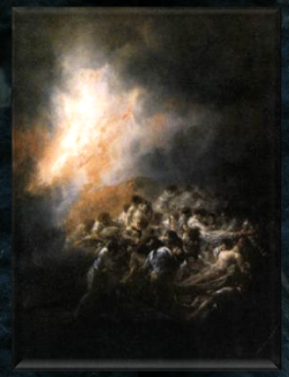

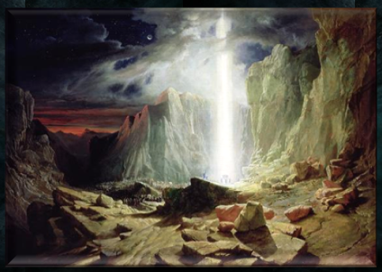

Isaiah 4:6 “And there shall be a tabernacle for a shadow in the daytime from the heat, and for a place of refuge, and for a covert from storm and from rain.” ^{KJV}
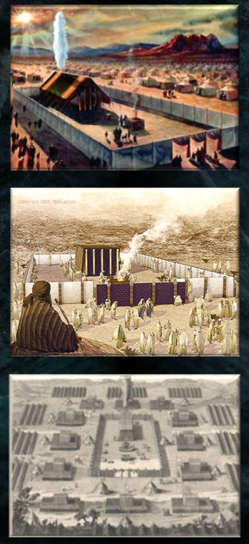

2 Maccabees 2:2-8 “And how that the prophet, having given them the law, charged them not to forget the commandments of the Lord, and they should not err in their minds, when they see images of silver and gold, with their ornaments. 3 And with other such speeches exhorted he them, that the law should not depart from their hearts. 4 It was also contained in the same writing, that the prophet, being warned of God, commanded the tabernacle and the dark to go with him, as he went forth into the mountain, where Moses climbed up, and saw the heritage of God. 5 And when Jeremiah came thither, he found an hollow cave, wherein he laid the tabernacle, and the ark, and the altar of incense, and so stopped the door. 6 And some of those that followed him came to mark the way, but they could not find it. 7 Which when Jeremiah perceived, he blamed them, saying, As for that place, it shall be unknown, until the time that God gather his people again together, and receive them unto mercy. 8 Then shall the Lord shew them these things, and the glory of the Lord shall appear, and the cloud also, as it was shewed under Moses, and as when Solomon desired that the place might be honourably sanctified.”

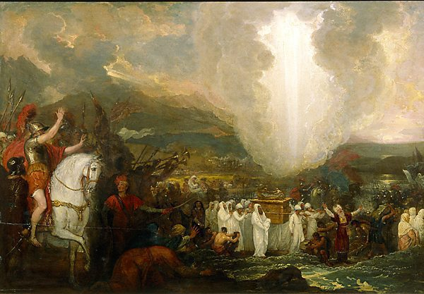
1 Enoch 1:1-8 “The words of the blessing of Enoch, wherewith he blessed the elect and righteous who will be living in the day of tribulation, when all the wicked and godless are to be removed. 2 And he took up his parable and said -Enoch a righteous man, whose eyes were opened by God, saw the vision of the Holy One in the heavens, which the angels showed me, and from them I heard everything, and from them I understood as I saw, but not for this generation, but for a remote one which is for to come. 3 Concerning the elect I said, and took up my parable concerning them: The Holy Great One will come forth from His dwelling, 4 And the external God will tread upon the earth, (even) on Mount Sinah [And appear from His camp] And appear in the strength of His might from the heaven of heavens. 5 And all shall be smitten with fear, And the Watchers shall quake, And great fear and trembling shall seize them unto the ends of the earth. 6 And the high mountains shall be shaken, And the high hills shall be made low, And shall melt like wax before the flame 7 And the earth shall be wholly rent in sunder, And all that is upon the earth shall perish, And there shall be judgement upon all (men). 8 But with the righteous He will make peace, And will protect the elect, And mercy shall be upon them. And they shall all belong to God, And they shall be prospered, And they shall all be blessed. And He will help them all, And light shall appear unto them, And He will make peace with them.” ^{R.H. Charles}

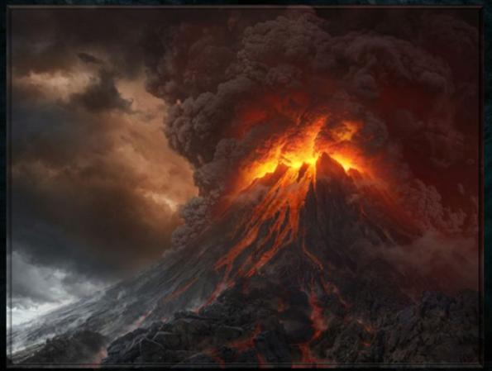
Cyclic Occurrences/Factors
Egypt  Exodus 1:8, Revelation 11:8 | Affliction/Bondage  Exodus 1:10-14, Revelation 7:14 | Captivity  Exodus 1:10-14, Revelation 13:10 | Male Child Born  Exodus 1:16, 2:2, Revelation 12:4-5
Dragon Seeking to Destroy/Infanticide  Exodus 1:15-27, 2:15, Revelation 12:4, Ezekiel 29:3 ^{KJV} | Male Child Delivered  Exodus 1:18, 2:1-10, Revelation 12:5-6 | Encounters YHWH on Mountain of God  Exodus 3, 19, 24:13-18, Revelation 12:5, 14:1-5 | Faithful Provided Households/Mansions  Exodus 1:21, John 14:2
7 Daughters/Women  Exodus 2:16,  Revelation 2:1–3:22 | Miraculous Rod/Subjection  Exodus 4:2, 17, Revelation 2:26-27 | Two Witnesses  Exodus 4:16, Revelation 11:3 | Spiritual Manipulation of Kings  Exodus 4:21, Revelation 17:17
False Signs/Wonders  Exodus 7:11, 22, 8:7, 18, Revelation 13:13-14, 16:14, 19:20, Matthew 24:24 | Waters Becoming Blood  Exodus 7:14-25, Revelation 8:8, 11:6, 16:3-4 | Frogs  Exodus 8:1-14, Revelation 16:13 | Lice/Flies/Pestilence  Exodus 8:16-9:7, Revelation 6:8 ^{NASB}, Matthew 24:7 ^{KJV}
Boils/Sores Upon Kingdoms of the Beast  Exodus 9:8-11, Revelation 16:2,11 | Hail/Fire  Exodus 9:13-35, Revelation 8:7 | Supernaturally Sized Hail  Exodus 9:24, Revelation 16:21 (100lbs ^{NASB}) | Thunder/Hail  Exodus 9:23, 28-29, 33-34, Revelation 11:19
Locusts  Exodus 10:1-20, Revelation 9:3, 7 | Supernatural Darkness  Exodus 10:21-23, Revelation 16:10, 8:12 | Defend/Victory by Blood  Exodus 12:13, Revelation 12:11 | Destroyer  Exodus 12:23, Revelation 9:11 (^{MSTC, Living Bible})
Exodus into Wilderness  Exodus 12:31-14:21, Revelation 12 | Given/Bore Upon Eagles’ Wings  Exodus 19:2, Revelation 12:14 | Pursuit/Persecution into Wilderness  Exodus 14, Revelation 12:4-6 | Pursuers/Swallowed By Earth  Exodus 15:12, Revelation 12:16, Psalm 90:3-5, 18:16-17
Marking Upon Hand/Forehead  Exodus 13:9, 16, Revelation 13:16, 20:4 | Horses/Horsemen/Chariots  Exodus 14:9, Revelation 9:9, 16 | Song of Moses  Exodus 15:1-18, Revelation 15:3 | Bitter/Poisonous Waters  Exodus 15:23, Revelation 8:11

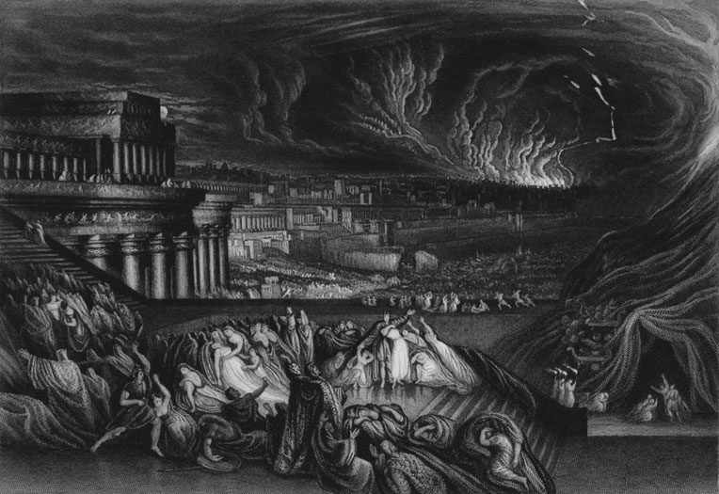
Valley of achor

Isaiah 65:8-10 “Thus saith the LORD, As the new wine is found in the cluster, and [one] saith, Destroy it not; for a blessing [is] in it: so will I do for my servants' sakes, that I may not destroy them all.9 And I will bring forth a seed out of Jacob, and out of Judah an inheritor of my mountains: and mine elect shall inherit it, and my servants shall dwell there.10 And Sharon shall be a fold of flocks, and the valley of Achor a place for the herds to lie down in, for my people that have sought me.” ^{KJV} (See also Song of Solomon 2:1)
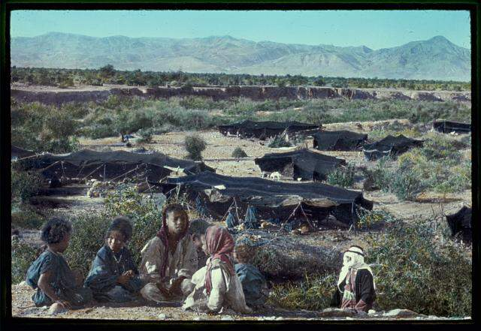
Hosea 2:14-20 “Therefore, behold, I will allure her, and bring her into the wilderness, and speak comfortably unto her.15 And I will give her her vineyards from thence, and the valley of Achor for a door of hope: and she shall sing there, as in the days of her youth, and as in the day when she came up out of the land of Egypt.16 And it shall be at that day, saith the LORD, [that] thou shalt call me Ishi; and shalt call me no more Baali.17 For I will take away the names of Baalim out of her mouth, and they shall no more be remembered by their name.18 And in that day will I make a covenant for them with the beasts of the field, and with the fowls of heaven, and [with] the creeping things of the ground: and I will break the bow and the sword and the battle out of the earth, and will make them to lie down safely.19 And I will betroth thee unto me for ever; yea, I will betroth thee unto me in righteousness, and in judgment, and in lovingkindness, and in mercies.20 I will even betroth thee unto me in faithfulness: and thou shalt know the LORD.” ^{KJV}
Bozrah

Micah 2:12-13 “I will surely assemble, O Jacob, all of thee; I will surely gather the remnant of Israel; I will put them together as the sheep of Bozrah, (as the) flock in the midst of their fold: they shall make great noise by reason of [the multitude of] men. 13 The breaker is come up before them: they have broken up, and have passed through the gate, and are gone out by it: and their king shall pass before them, and the LORD on the head of them.” ^{KJV}

Jeremiah 49:22 “Behold, he shall come up and fly as the eagle, and spread his wings over Bozrah: and at that day shall the heart of the mighty men of Edom be as the heart of a woman in her pangs.” ^{KJV}

Isaiah 63:1-6 “Who [is] this that cometh from Edom, with dyed garments from Bozrah? this [that is] glorious in his apparel, travelling in the greatness of his strength? I that speak in righteousness, mighty to save.2 Wherefore [art thou] red in thine apparel, and thy garments like him that treadeth in the winefat? 3 I have trodden the winepress alone; and of the people [there was] none with me: for I will tread them in mine anger, and trample them in my fury; and their blood shall be sprinkled upon my garments, and I will stain all my raiment.4 For the day of vengeance [is] in mine heart, and the year of my redeemed is come. 5 And I looked, and [there was] none to help; and I wondered that [there was] none to uphold: therefore mine own arm brought salvation unto me; and my fury, it upheld me.6 And I will tread down the people in mine anger, and make them drunk in my fury, and I will bring down their strength to the earth.” ^{KJV}

See also Zechariah 9:14-16, Isaiah 34, 35:4, Song of Solomon 8:5

Highways

Isaiah 62:10-12 “Go through, go through the gates; prepare ye the way of the people; cast up, cast up the highway; gather out the stones; lift up a standard for the people.11 Behold, the LORD hath proclaimed unto the end of the world, Say ye to the daughter of Zion, Behold, thy salvation cometh; behold, his reward [is] with him, and his work before him.12 And they shall call them, The holy people, The redeemed of the LORD: and thou shalt be called, Sought out, A city not forsaken.” ^{KJV}

Isaiah 35:7-10 “And the parched ground shall become a pool, and the thirsty land springs of water: in the habitation of dragons, where each lay, [shall be] grass with reeds and rushes.8 And an highway shall be there, and a way, and it shall be called The way of holiness; the unclean shall not pass over it; but it [shall be] for those: the wayfaring men, though fools, shall not err [therein].9 No lion shall be there, nor [any] ravenous beast shall go up thereon, it shall not be found there; but the redeemed shall walk [there]:10 And the ransomed of the LORD shall return, and come to Zion with songs and everlasting joy upon their heads: they shall obtain joy and gladness, and sorrow and sighing shall flee away.” ^{KJV}

Proverbs 15:19 “The way of the lazy is as a hedge of thorns, But the path of the upright is a highway.” N^{KJV}

Proverbs 16:17 “The highway of the upright is to depart from evil; He who watches his way preserves his life.” ^{NKJV}

See also Isaiah 11:16, 19:23

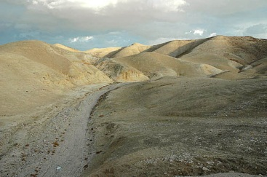
YAHUSHUA

Matthew 24:37-42 “But as the days of Noe [were], so shall also the coming of the Son of man be. 38 For as in the days that were before the flood they were eating and drinking, marrying and giving in marriage, until the day that Noe entered into the ark, 39 And knew not until the flood came, and took them all away; so shall also the coming of the Son of man be. 40 Then shall two be in the field; the one shall be taken, and the other left. 41 Two [women shall be] grinding at the mill; the one shall be taken, and the other left. 42 Watch therefore: for ye know not what hour your Lord doth come.” ^{KJV}

JEREMIAH

Jeremiah 23:7-8 “Therefore, behold, the days come, saith the LORD, that they shall no more say, The LORD liveth, which brought up the children of Israel out of the land of Egypt; 8 But, The LORD liveth, which brought up and which led the seed of the house of Israel out of the north country, and from all countries whither I had driven them; and they shall dwell in their own land. “ ^{KJV}

See also Jeremiah 16:14-15

Jeremiah 30:23-31:2 “Behold, the whirlwind of the LORD goeth forth with fury, a continuing whirlwind: it shall fall with pain upon the head of the wicked. 24 “The fierce anger of the LORD shall not return, until he have done [it], and until he have performed the intents of his heart: in the latter days ye shall consider it. 1 At the same time, saith the LORD, will I be the God of all the families of Israel, and they shall be my people. 2 Thus saith the LORD, The people [which were] left of the sword found grace in the wilderness; [even] Israel, when I went to cause him to rest.” ^{KJV}

ISAIAH

Isaiah 43:19-21 “Behold, I will do a new thing; now it shall spring forth; shall ye not know it? I will even make a way in the wilderness, [and] rivers in the desert. 20 The beast of the field shall honour me, the dragons and the owls: because I give waters in the wilderness, [and] rivers in the desert, to give drink to my people, my chosen. 21 This people have I formed for myself; they shall shew forth my praise.” ^{KJV}

Isaiah 53:1 “For the LORD shall comfort Zion: he will comfort all her waste places; and he will make her wilderness like Eden, and her desert like the garden of the LORD; joy and gladness shall be found therein, thanksgiving, and the voice of melody.” ^{KJV}

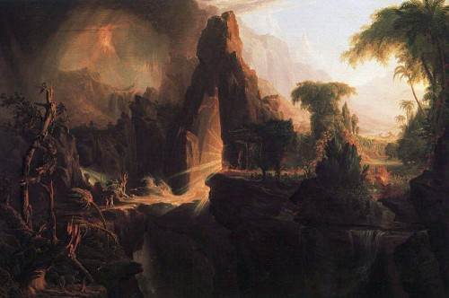

See also Isaiah 35
EZEKIEL/JOEL

Ezekiel 20:33-44 “[As] I live, saith the Lord GOD, surely with a mighty hand, and with a stretched out arm, and with fury poured out, will I rule over you: 34 And I will bring you out from the people, and will gather you out of the countries wherein ye are scattered, with a mighty hand, and with a stretched out arm, and with fury poured out. 35 And I will bring you into the wilderness of the people, and there will I plead with you face to face. 36 Like as I pleaded with your fathers in the wilderness of the land of Egypt, so will I plead with you, saith the Lord GOD. 37 And I will cause you to pass under the rod, and I will bring you into the bond of the covenant: 38 And I will purge out from among you the rebels, and them that transgress against me: I will bring them forth out of the country where they sojourn, and they shall not enter into the land of Israel: and ye shall know that I [am] the LORD. 39 As for you, O house of Israel, thus saith the Lord GOD; Go ye, serve ye every one his idols, and hereafter [also], if ye will not hearken unto me: but pollute ye my holy name no more with your gifts, and with your idols. 40 For in mine holy mountain, in the mountain of the height of Israel, saith the Lord GOD, there shall all the house of Israel, all of them in the land, serve me: there will I accept them, and there will I require your offerings, and the firstfruits of your oblations, with all your holy things. 41 I will accept you with your sweet savour, when I bring you out from the people, and gather you out of the countries wherein ye have been scattered; and I will be sanctified in you before the heathen. 42 And ye shall know that I [am] the LORD, when I shall bring you into the land of Israel, into the country [for] the which I lifted up mine hand to give it to your fathers. 43 And there shall ye remember your ways, and all your doings, wherein ye have been defiled; and ye shall lothe yourselves in your own sight for all your evils that ye have committed. 44 And ye shall know that I [am] the LORD, when I have wrought with you for my name's sake, not according to your wicked ways, nor according to your corrupt doings, O ye house of Israel, saith the Lord GOD.” ^{KJV}

Joel 3:15-16 “The sun and the moon shall be darkened, and the stars shall withdraw their shining.16 The LORD also shall roar out of Zion, and utter his voice from Jerusalem; and the heavens and the earth shall shake: but the LORD [will be]the hope of his people, and the strength of the children of Israel” ^{KJV}
Psalm 68:22 “The Lord said, I will bring again from Bashan, I will bring [my people] again from the depths of the sea” ^{KJV}

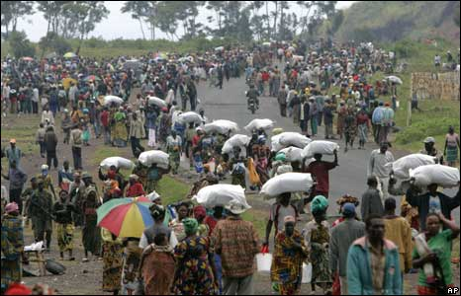

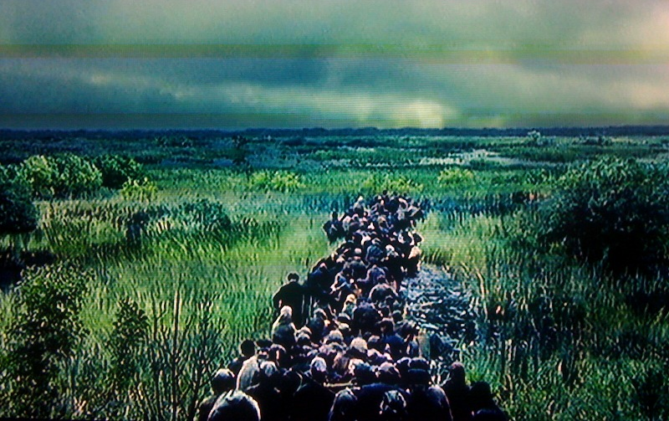

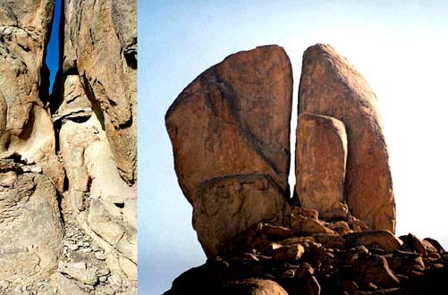

Exd 3:1 | ¶ | Now Moses ⁴⁸⁷² kept ¹⁹⁶¹ ⁷⁴⁶² the flock ⁶⁶²⁹ of Jethro ³⁵⁰³ his father in law ²⁸⁵⁹ , the priest ³⁵⁴⁸ of Midian ⁴⁰⁸⁰: and he led ⁵⁰⁹⁰ the flock ⁶⁶²⁹ to the backside ³¹⁰ of the desert ⁴⁰⁵⁷, and came ⁹³⁵ to the mountain ²⁰²² of God ⁴³⁰, [even] to Horeb ²⁷²².

^{MAKE A RENDITION}

